TIME SERIES ANALYSIS

PREPARED BY:

KAILASH S

|  |  |  |
| --- | --- | --- |
| **S.no** | **Content** | **Page number** |
| 1 | Project statement | 3 |
| 2 | Project overview | 3 |
| 3 | Project requirements | 3 |
| 3.1 | Azure subscription | 3 |
| 3.2 | Data sources | 3 |
| 3.3 | Azure storage account | 3 |
| 3.4 | Azure databricks | 3 |
| 4 | Architecture diagram | 4 |
| 5 | Tools used in project | 4 |
| 6 | Execution overview | 4 |
| 7 | Implementation on azure portal | 5 |
| 7.1 | Azure account | 5 |
| 7.2 | Create a blog storage account | 5 |
| 7.3 | Create a container | 8 |
| 7.4 | Upload a csv files in container | 10 |
| 7.5 | Creating the azure databricks workspace | 11 |
| 7.6 | Creating a cluster | 14 |
| 7.7 | Creating a notebook | 16 |
| 7.8 | Mounting the storage account in databricks | 16 |
| 7.9 | Finding Trends on files | 19 |
| 7.10 | Finding Seasonality on files | 23 |
| 7.11 | Anomaly detection on files | 26 |
| 7.12 | Unmount the storage account from databricks | 30 |
| 8 | Conclusion | 30 |

**1.Project Statement:** Implement time series analysis using PySparkSQL on Azure Databricks. Process and analyze time-stamped data for trends, seasonality, and anomalies.

**2.Project Overview:**

This project aims to leverage PySparkSQL on Azure Databricks to conduct time series analysis on time-stamped data. The objective is to identify trends, seasonality, and anomalies within the dataset. By utilizing the power of PySpark and the scalability of Azure Databricks, we can efficiently process large volumes of time series data for meaningful insights.

**3.Project Requirements:**

* Azure Subscription
* Data Sources
* Azure Storage account
* Azure Databricks
* Familiarity with time series analysis concepts.
* Visualization

**3.1.Azure Subscription:**

* A valid Azure subscription is required to access and utilize Azure services for hosting, managing, and analyzing data.

**3.2.Data Sources:**

* I downloaded a sample time-stamped file from the website called kaggle.From that I downloaded a file called “park-data.csv”.[Click here](https://www.kaggle.com)

**3.3.Azure Storage account:**

* Set up an Azure Storage account to store and manage the project's data efficiently, providing a scalable and secure solution for storing various types of data.

**3.4.Azure DataBricks:**

* Utilize Azure Databricks, a cloud-based big data analytics platform, to perform advanced analytics and data processing tasks, leveraging its collaborative and scalable environment.
* Time series analysis and Visualization done in Databricks.

**4.Architecture Diagram:**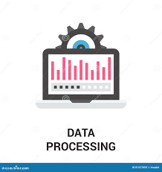

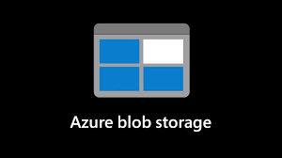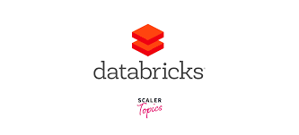





**5.Tools/Technology Used in Project:**

1. Azure Databricks
2. Azure Blob Storage
3. PySparkSQL
4. Notebooks for code execution and Visualization

**6.Execution Overview:**

* **Set Up Azure Databricks:**
  + Create an Azure Databricks workspace.
  + Configure necessary clusters and libraries.
* **Load Data from Blob Storage:**
  + Connect Azure Databricks to your Azure Storage Account.
  + Load time-stamped data into Spark DataFrame.
* **Implement Time Series Analysis:**
  + Use PySparkSQL for processing and analyzing time-stamped data.
  + Perform trend analysis, seasonality detection, and anomaly detection using appropriate queries.
* **Visualization:**
  + Utilize Databricks notebooks for interactive visualization.
  + Plot trends, seasonality, and anomalies.

**Steps - How to Implement:**

1. Set up an Azure Databricks environment.
2. Configure clusters and libraries.
3. Connect to Azure Blob Storage.
4. Load time-stamped data into Spark DataFrame.
5. Implement PySparkSQL queries for trend analysis.
6. Implement PySparkSQL queries for seasonality detection.
7. Implement PySparkSQL queries for anomaly detection.
8. Visualize the results using Databricks notebooks.

**7.Implementation on Azure portal:**

**7.1:Azure account**

* Login into the Azure portal

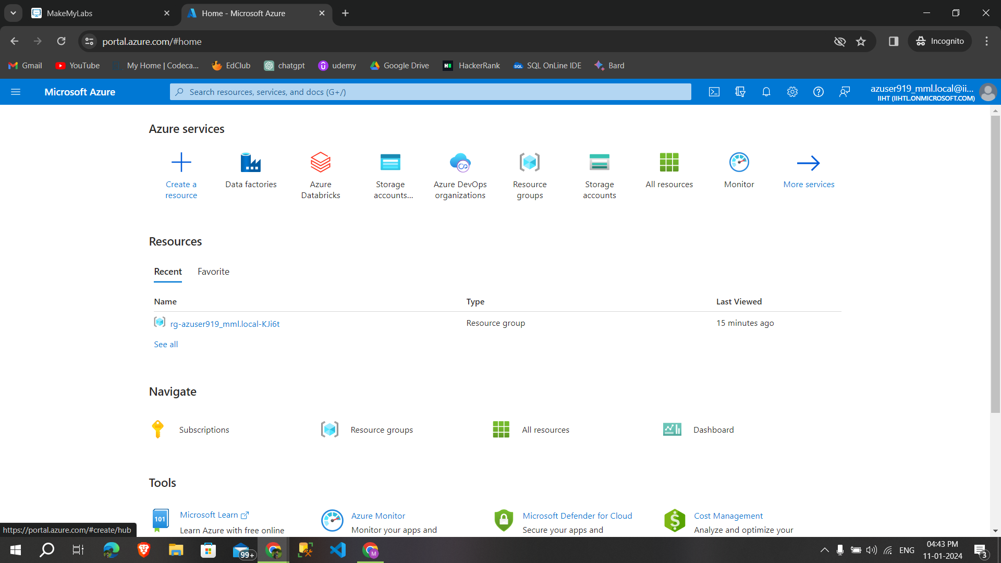

**7.2:Create a blog storage account**

**Step1 :**Create a storage account give appropriate resource group,name,region then **click→advanced**

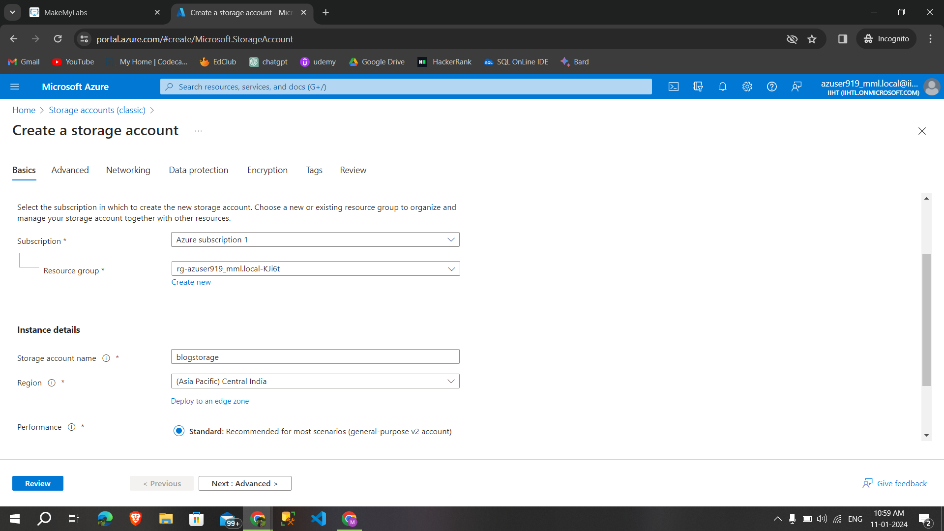

**Step2 :**Enable hierarchical namespace if needed then **click →networking**

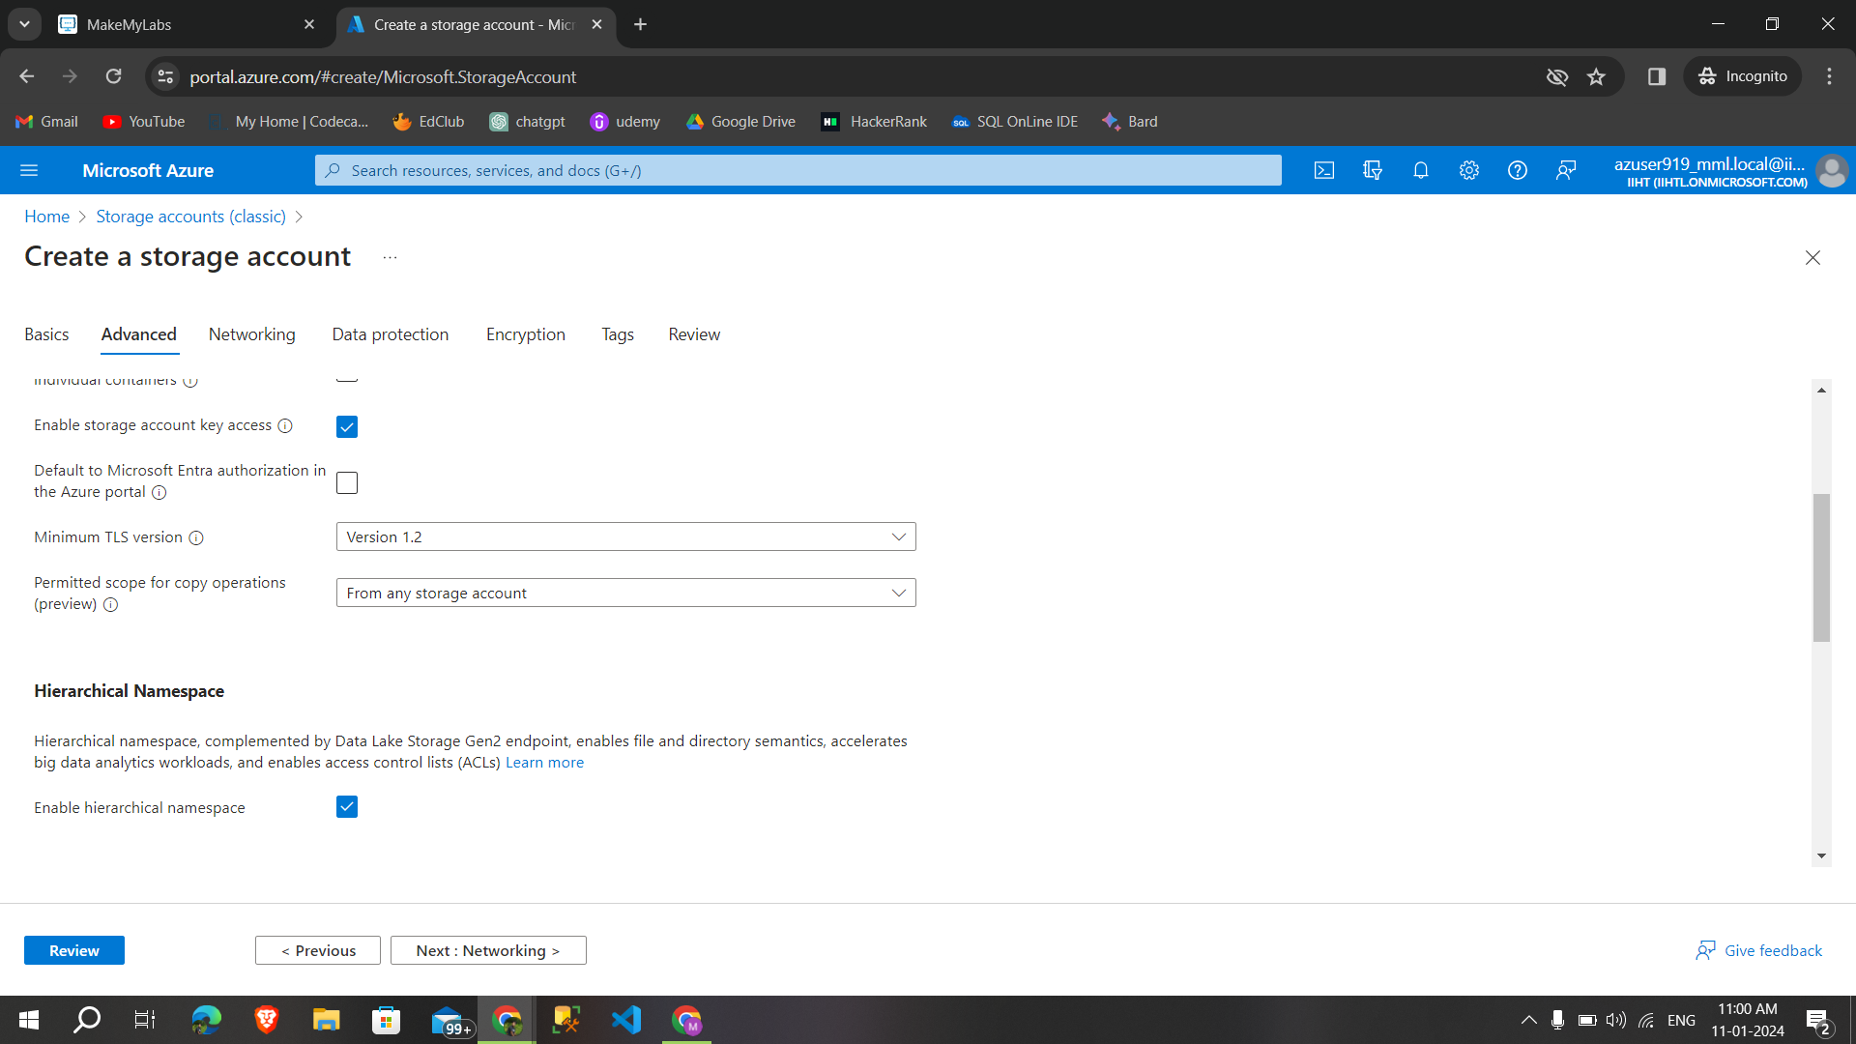

**Step3 :**After networking click on data protection for next steps,

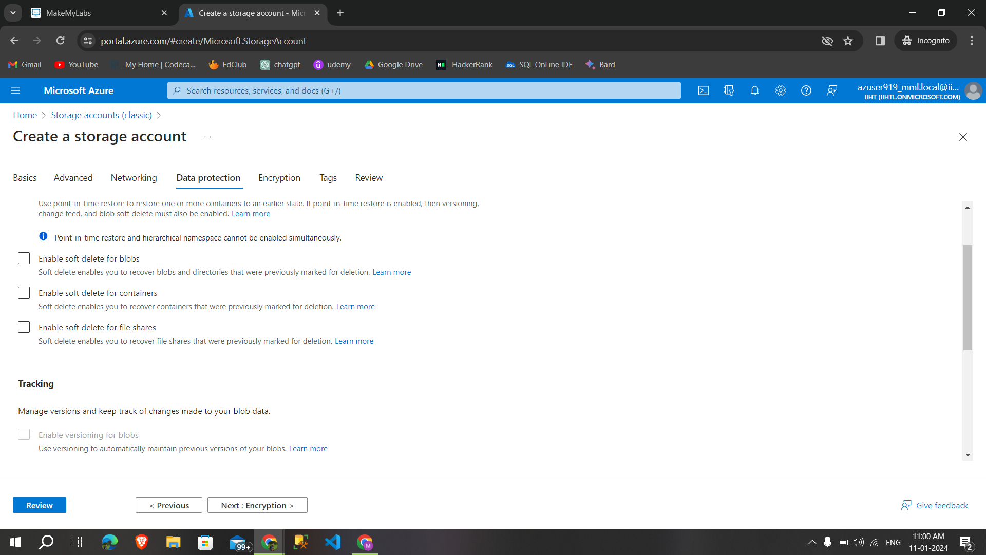

**Step 4 :**Then give the encryption type and **click→tags→review**

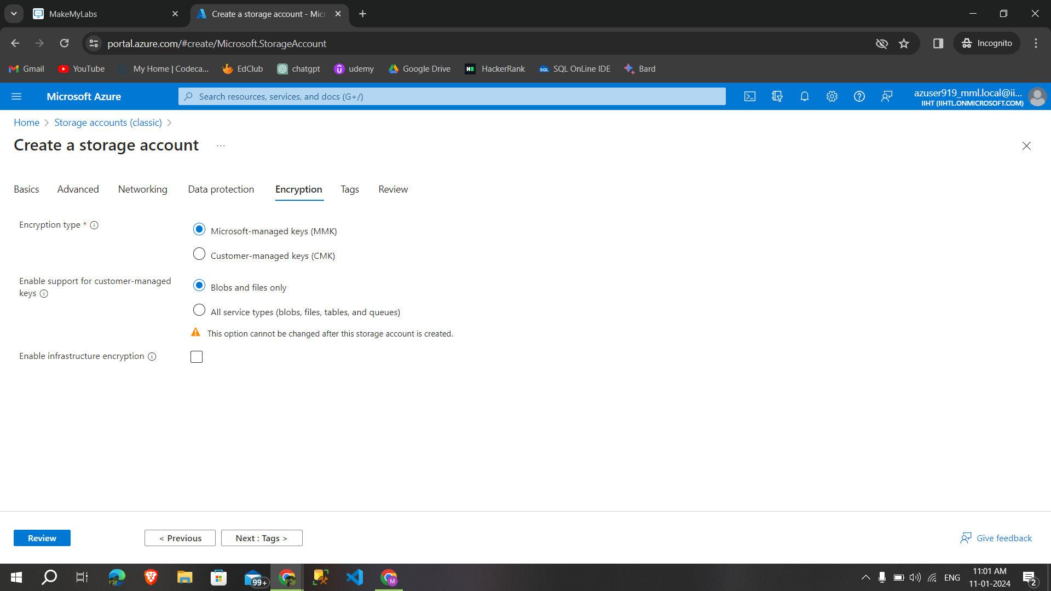

**Step 5:**After reviewing **click →create** ,to create a storage account

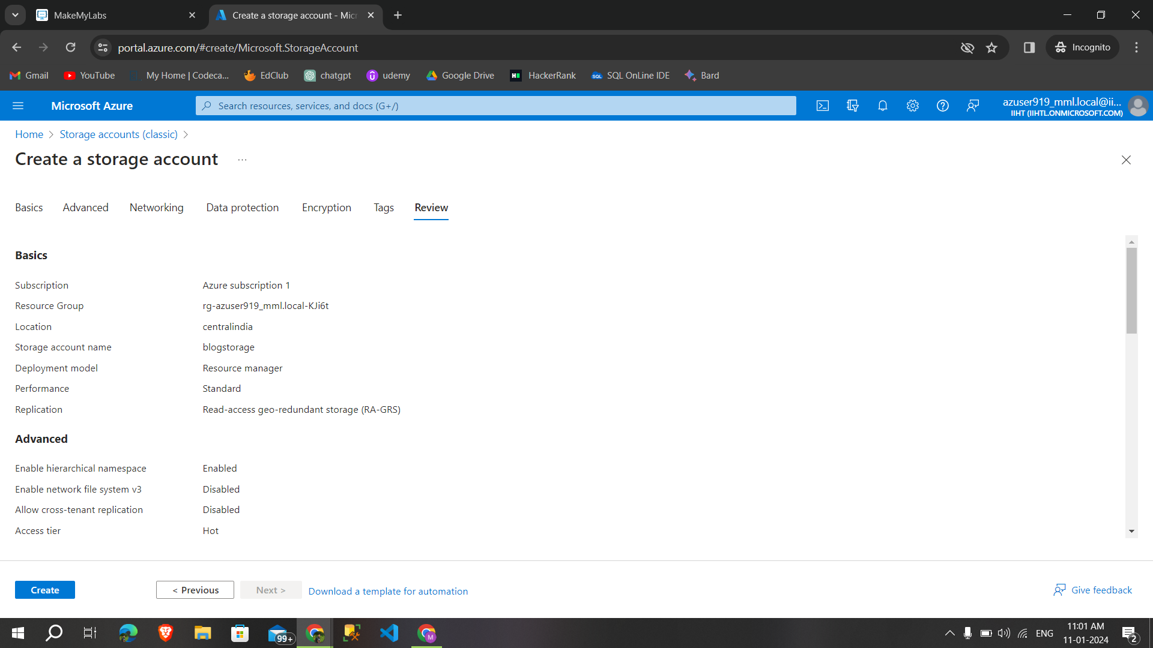

**Deployment is complete** ,created a storage account.

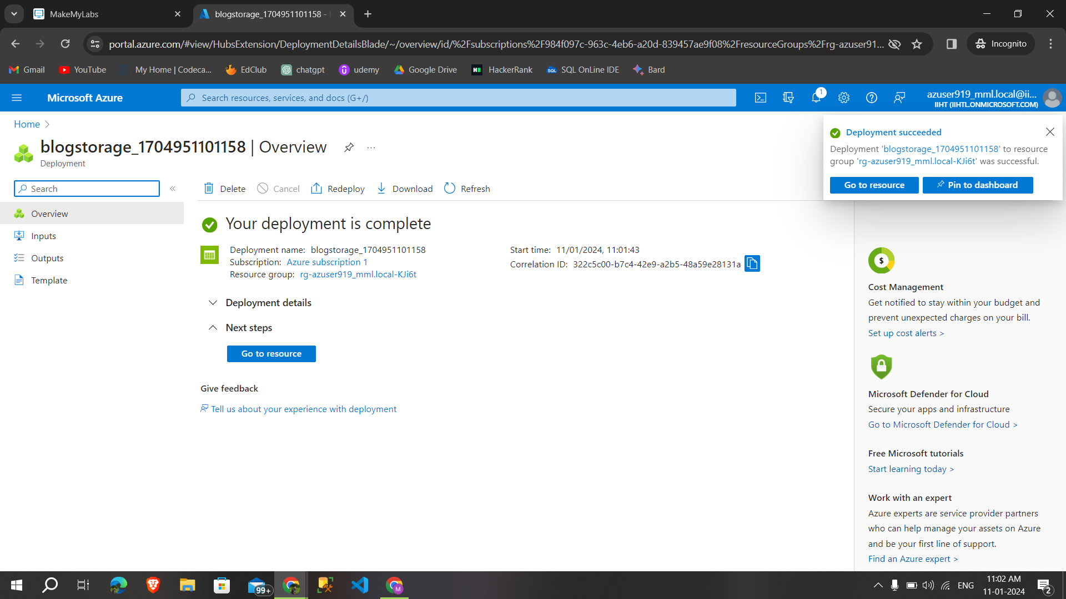

**7.3.Create a container**

**Step 1:**Click on containers to create a blog container

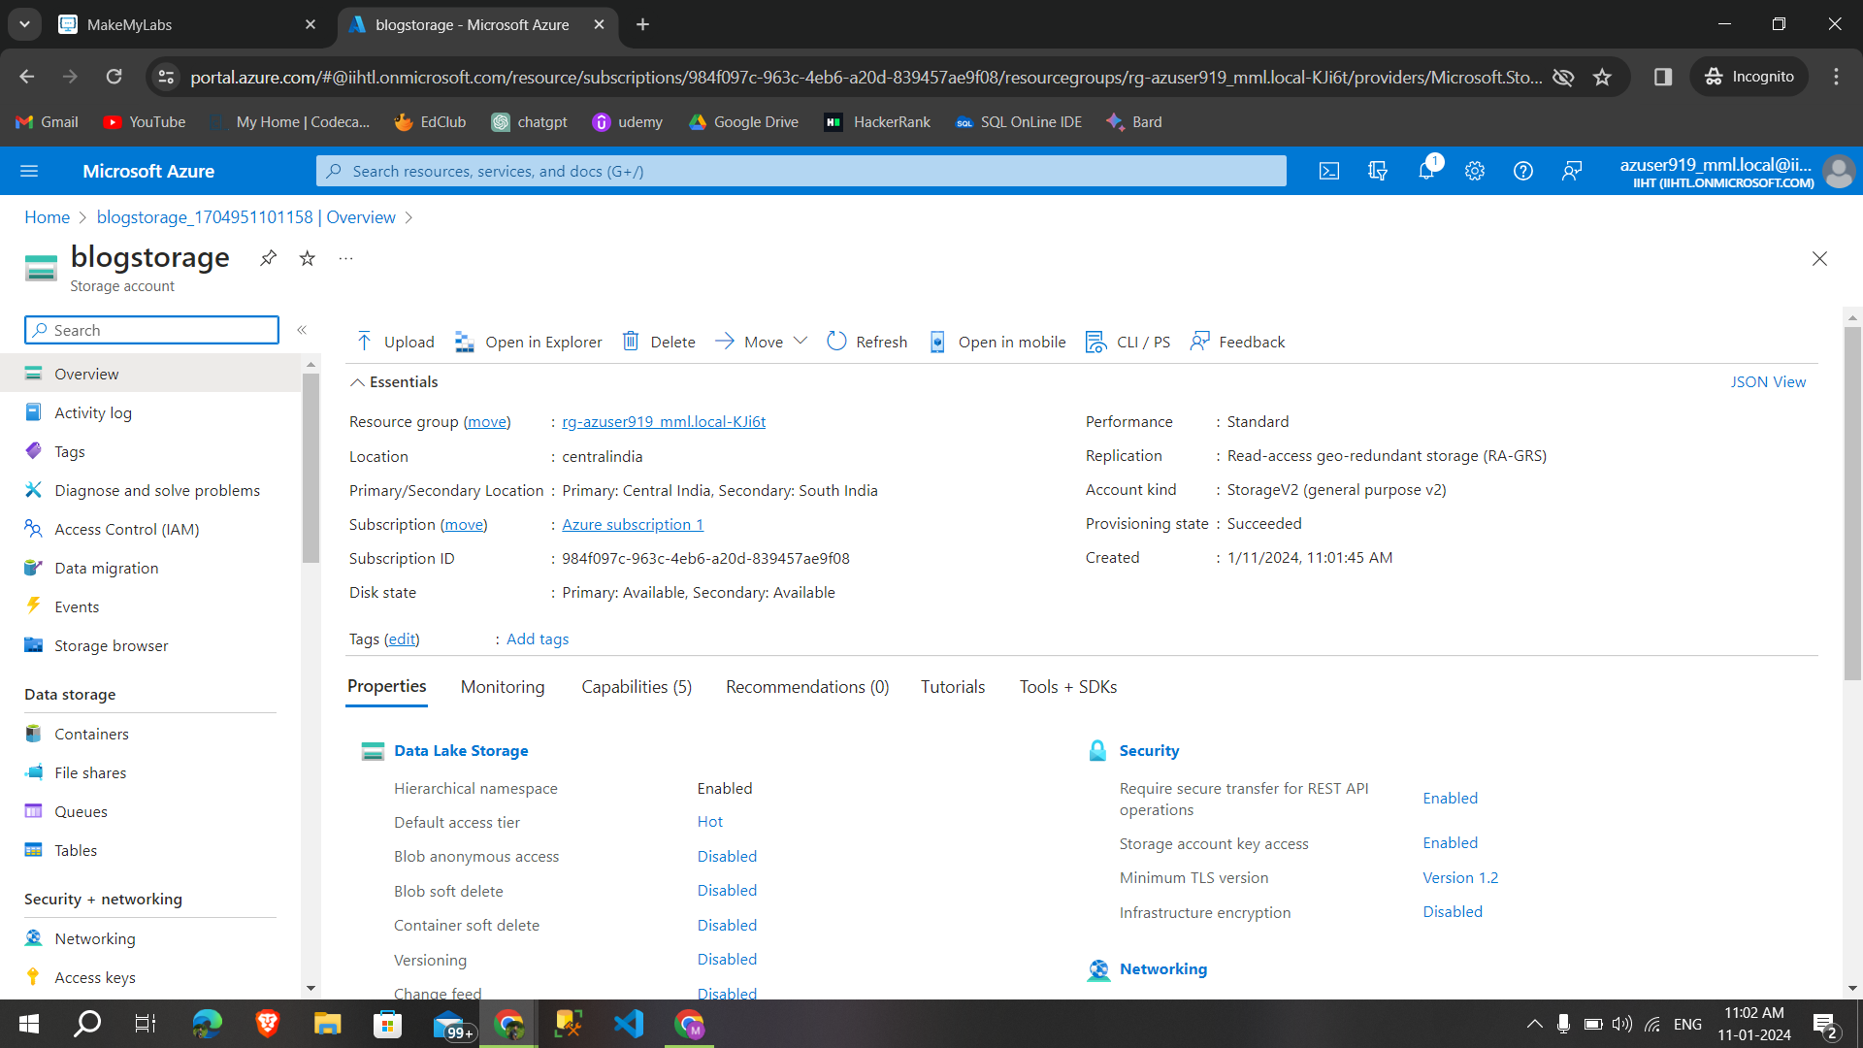

**Step 2:**Select container to create a new container

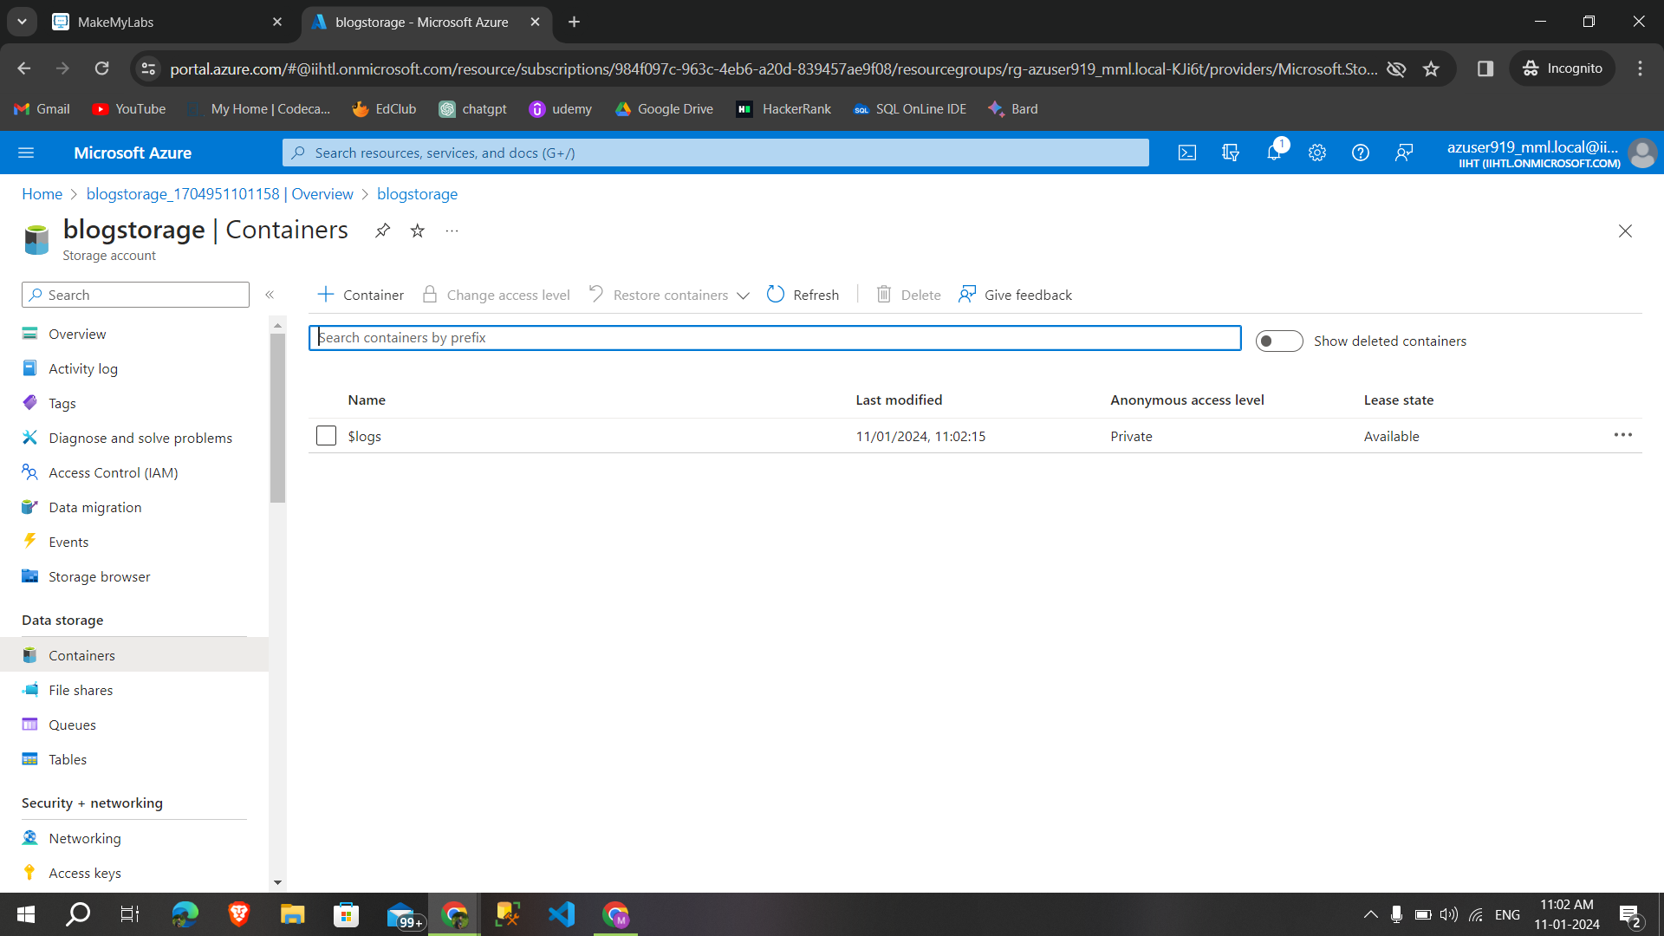

**Step 3:**Give a specific name(project) to your container and click on create

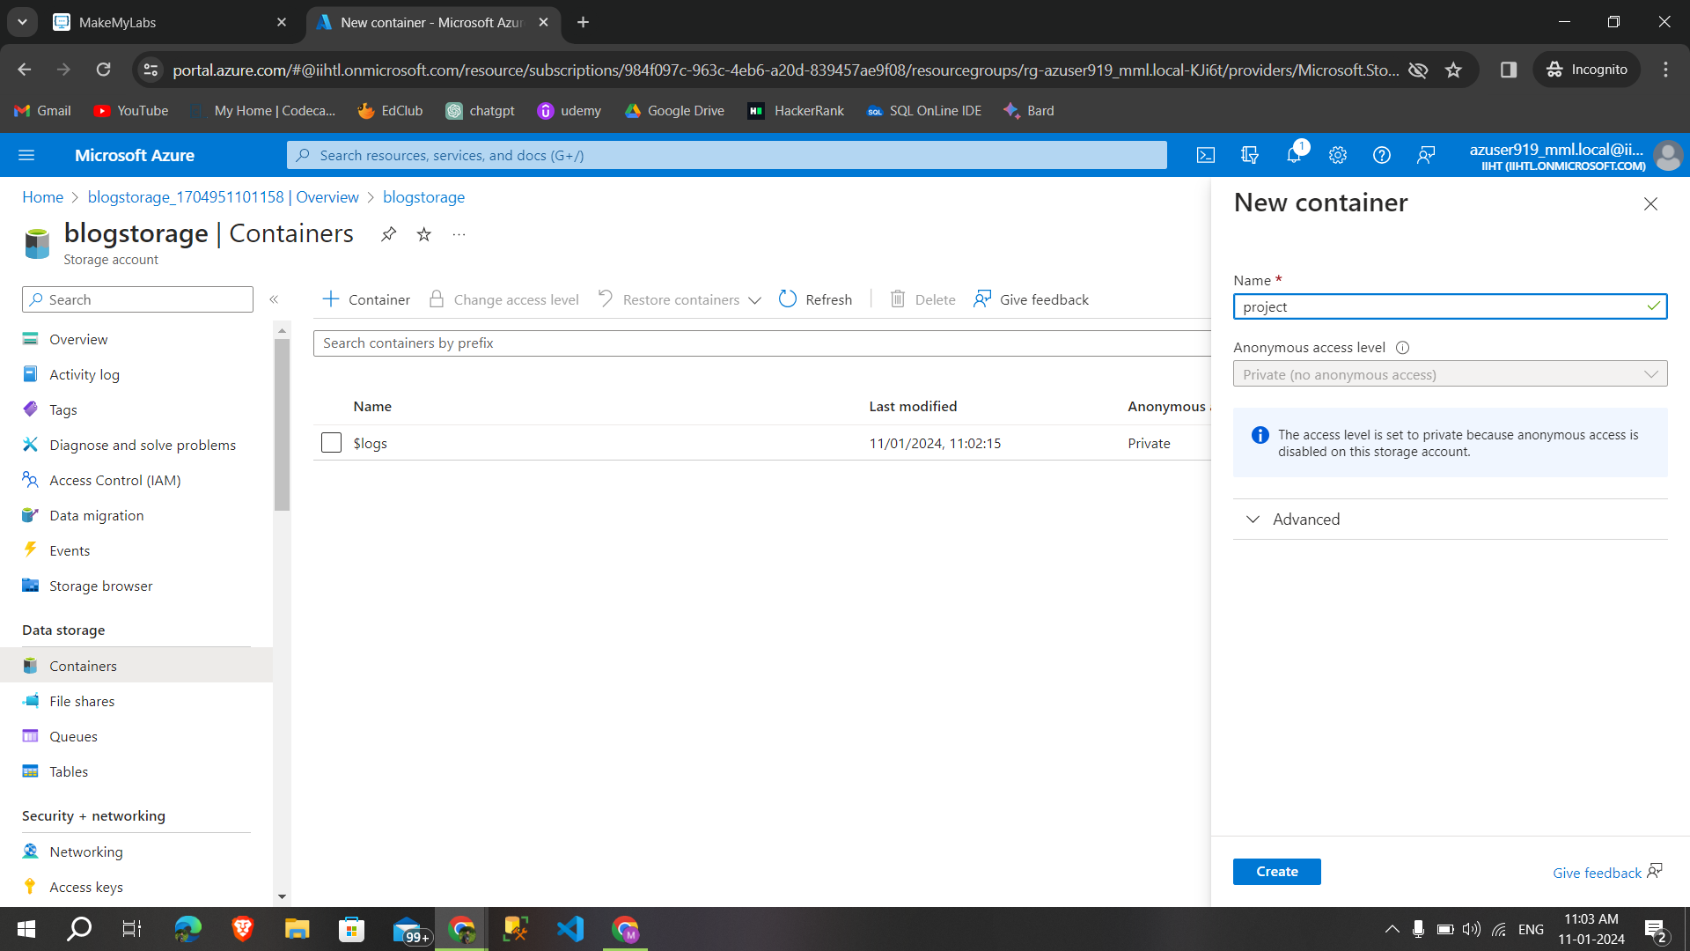

**7.4.Upload a csv files in container**

**Step 1:**Select upload option to upload time stamped data for analysis

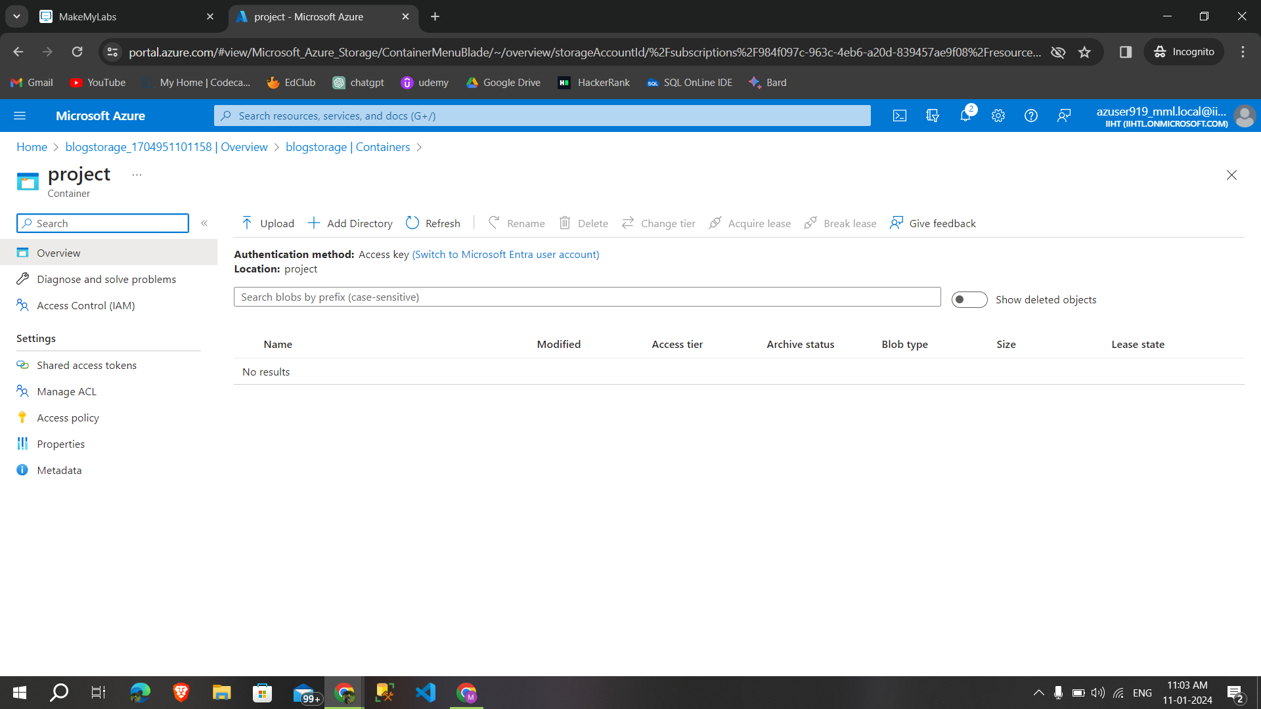

**Step 2:**Uploaded two files in the container

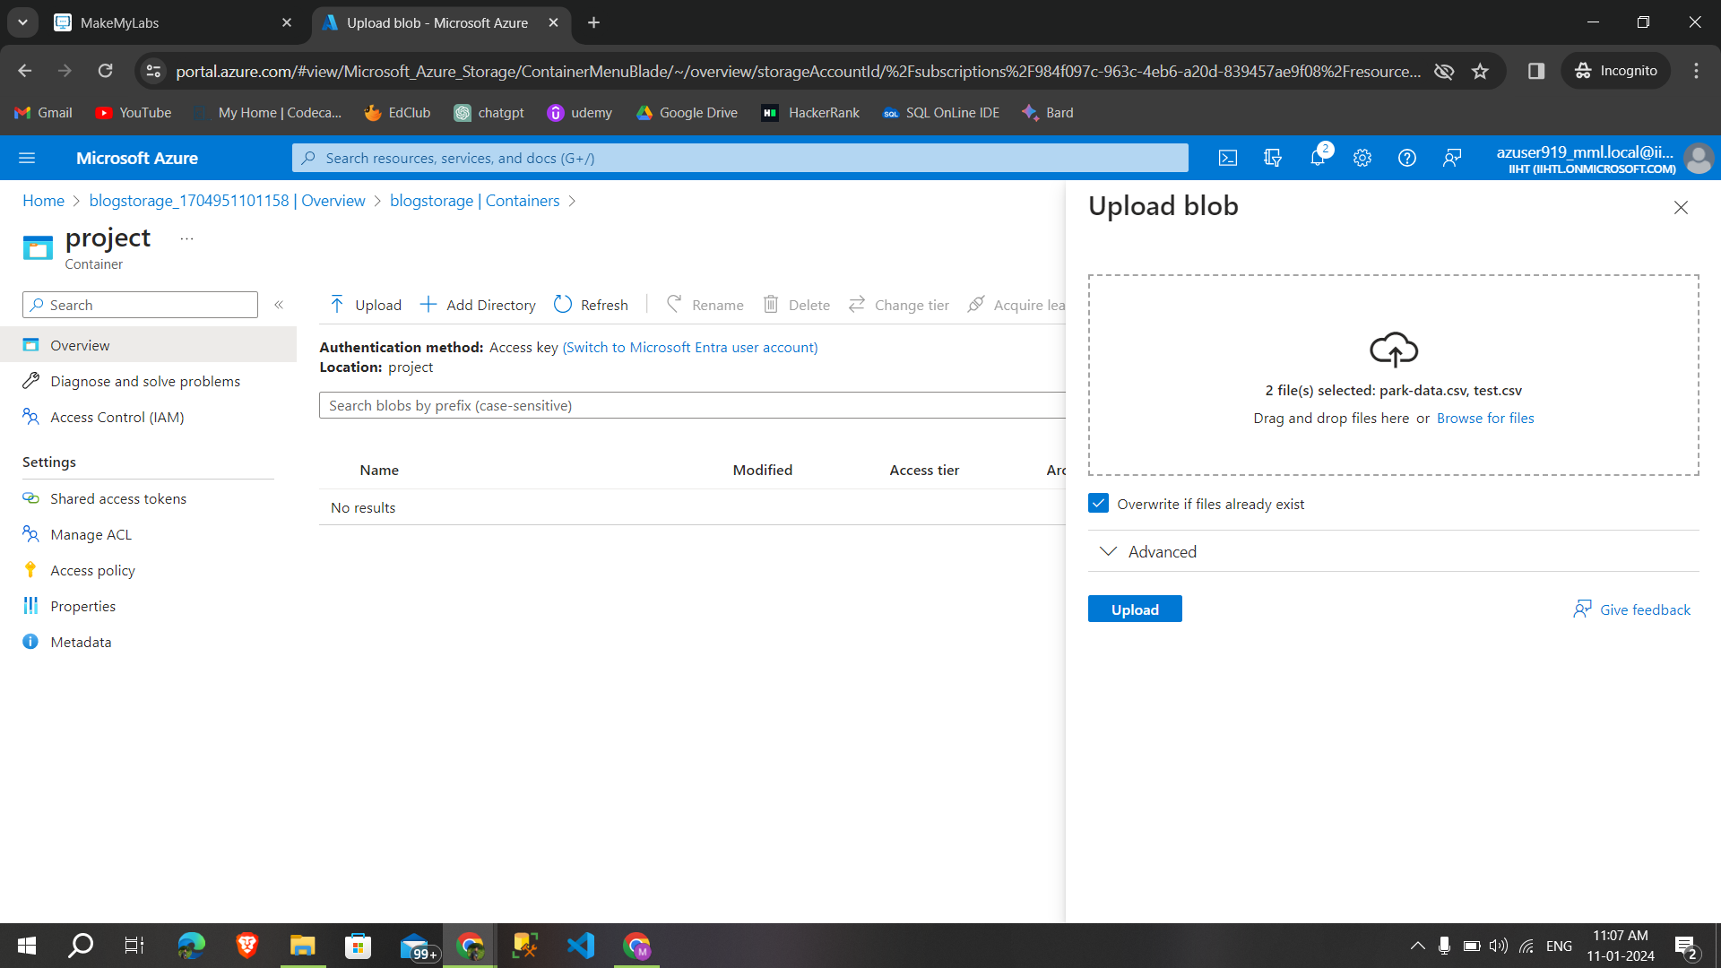

**Step 3:**Successfully added two files

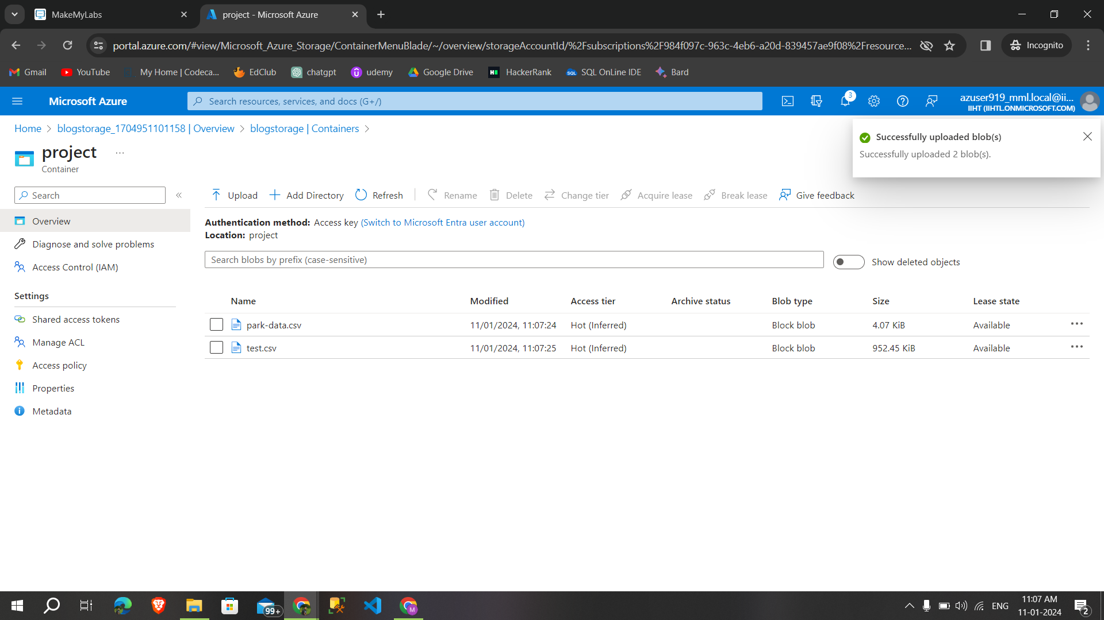

**7.5.Creating the azure databricks workspace**

**Step 1:**Search azure databricks in the azure portal and Select create to create a databricks Workspace

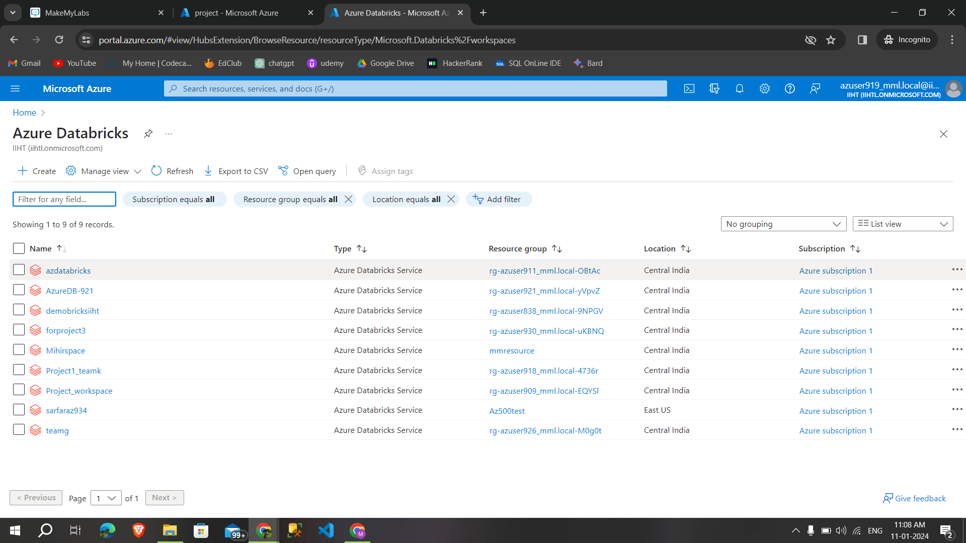

**Step 2**:After giving details like resource group,workspace name,region,pricing tier select→networking

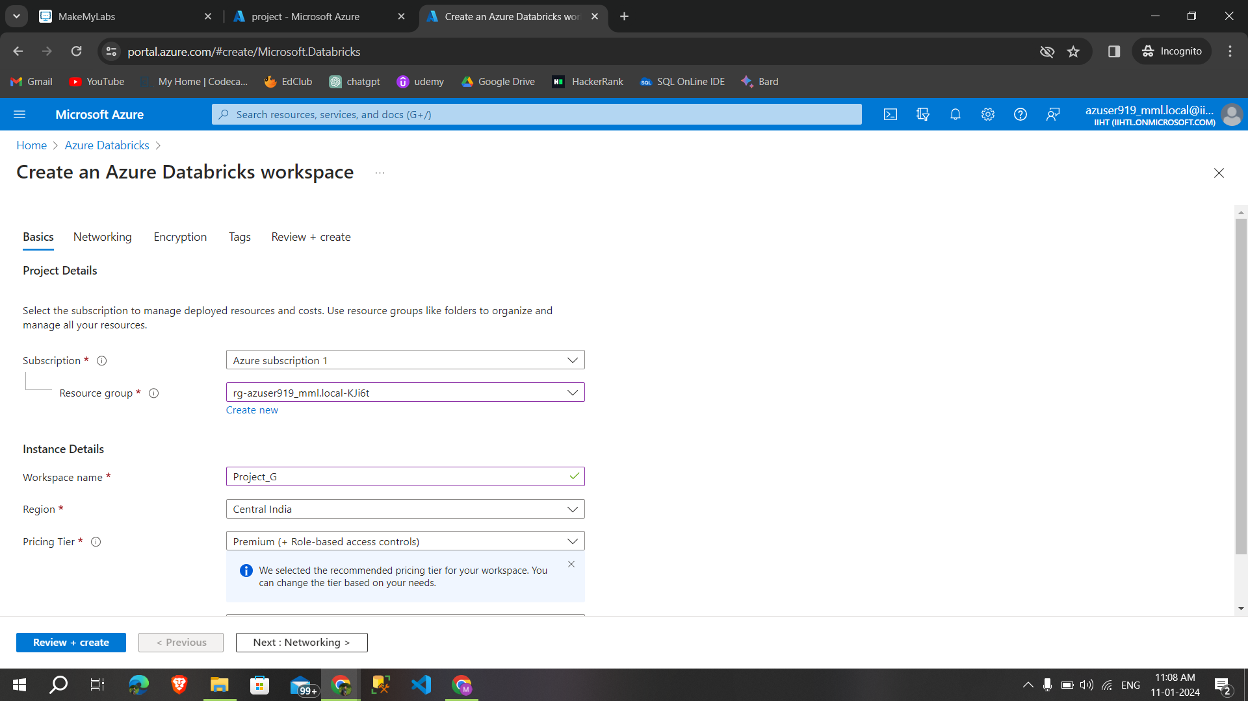

**Stpe 3:** Click on next and review and create

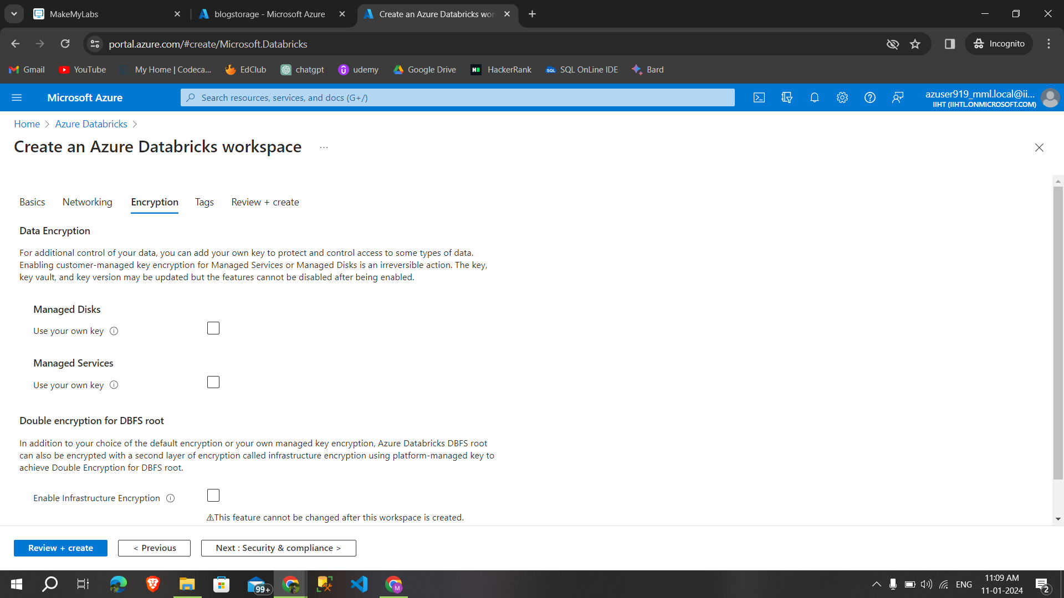

**Step 4:** After validation in success ,Select→create

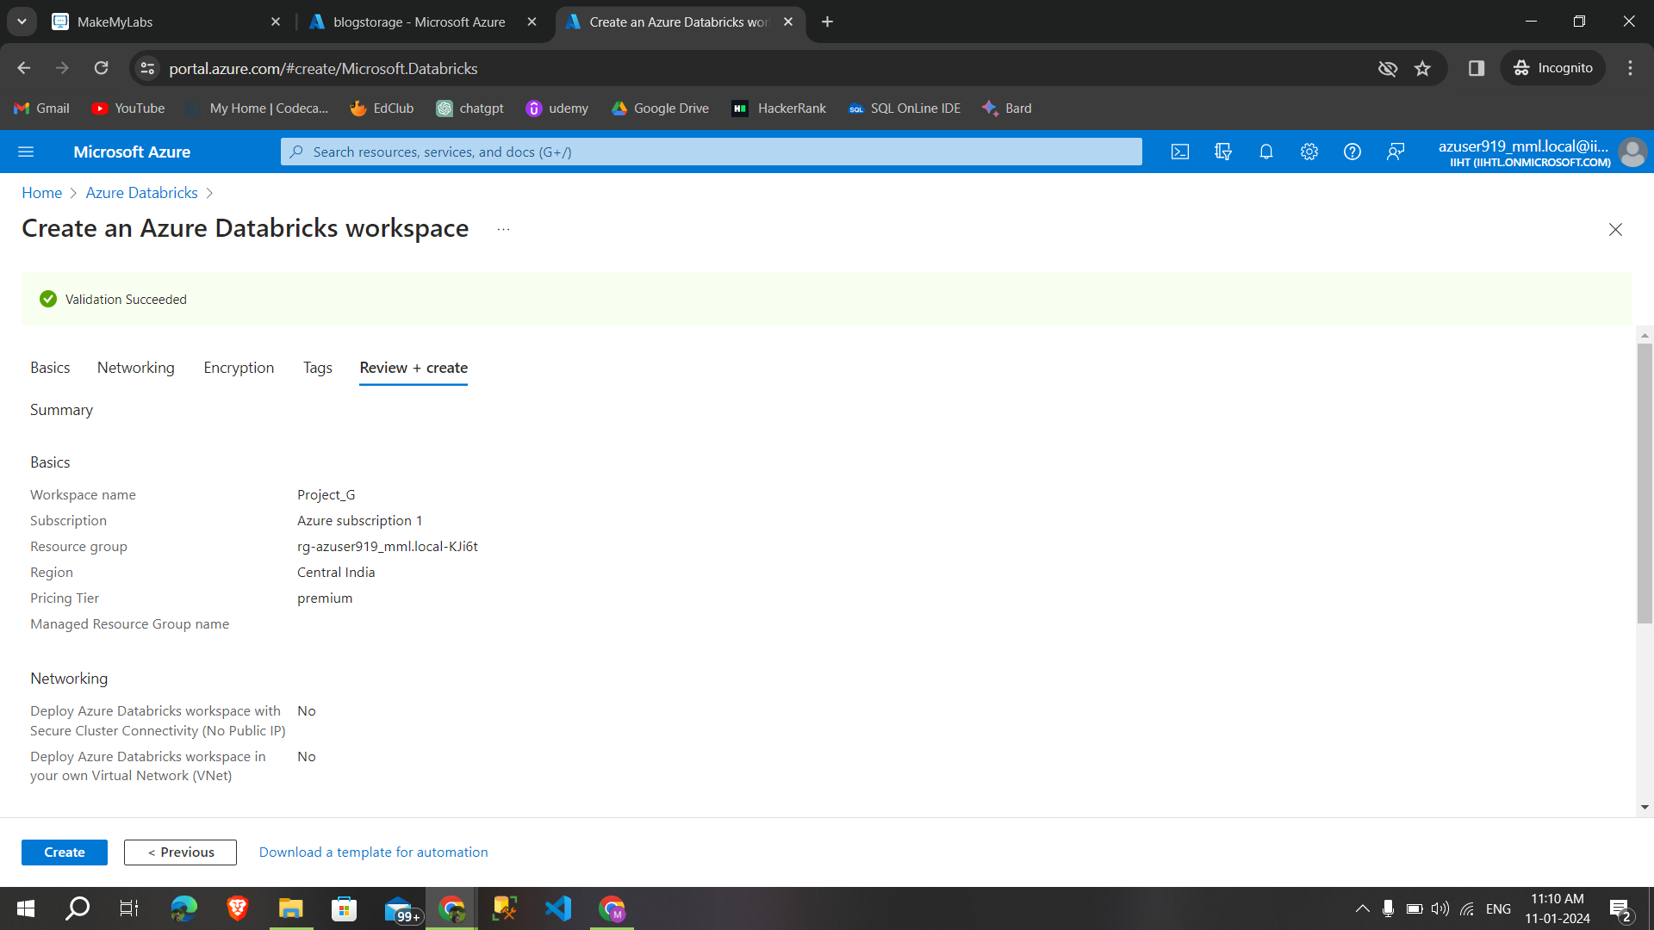

**Step 5:**Deployment is complete now click on go to resource

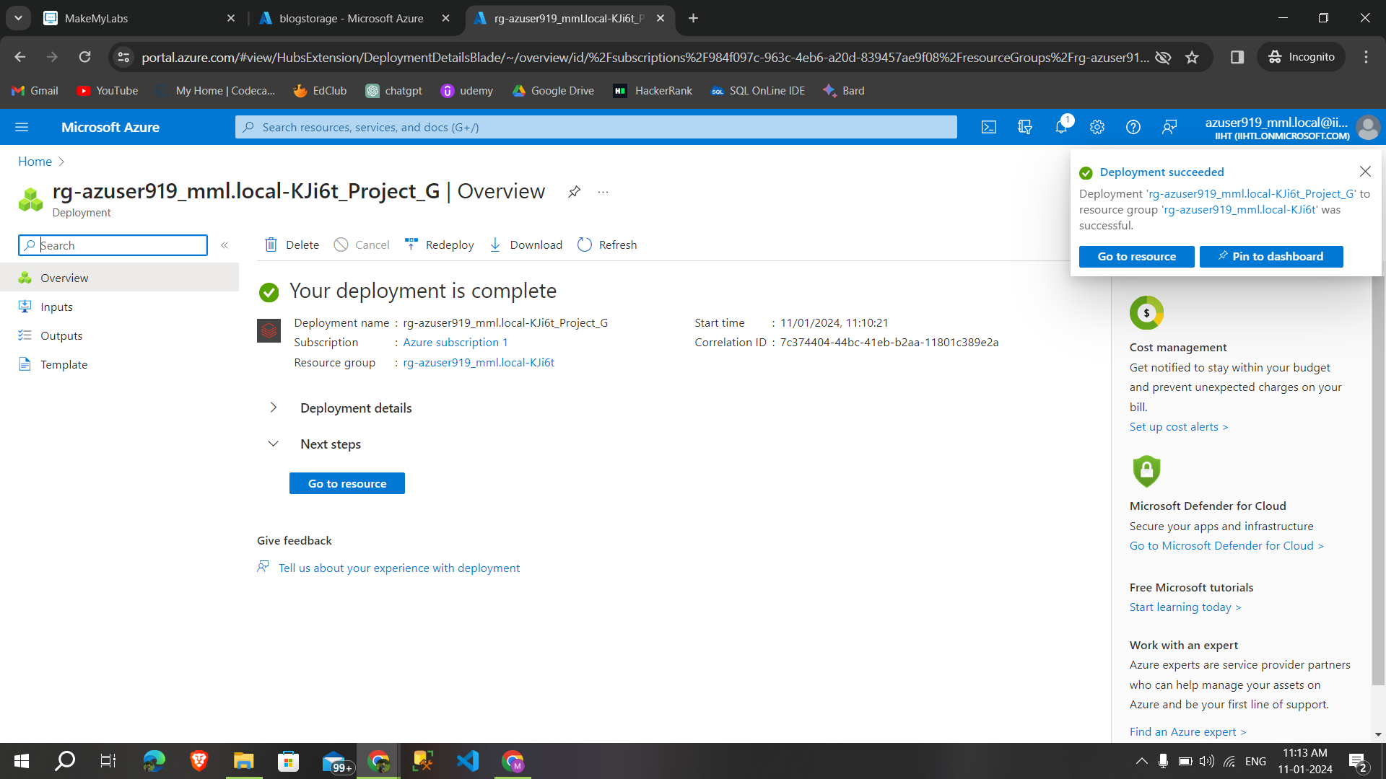

**7.6.Creating a cluster**

**Step 1**:Launch workspace to create cluster

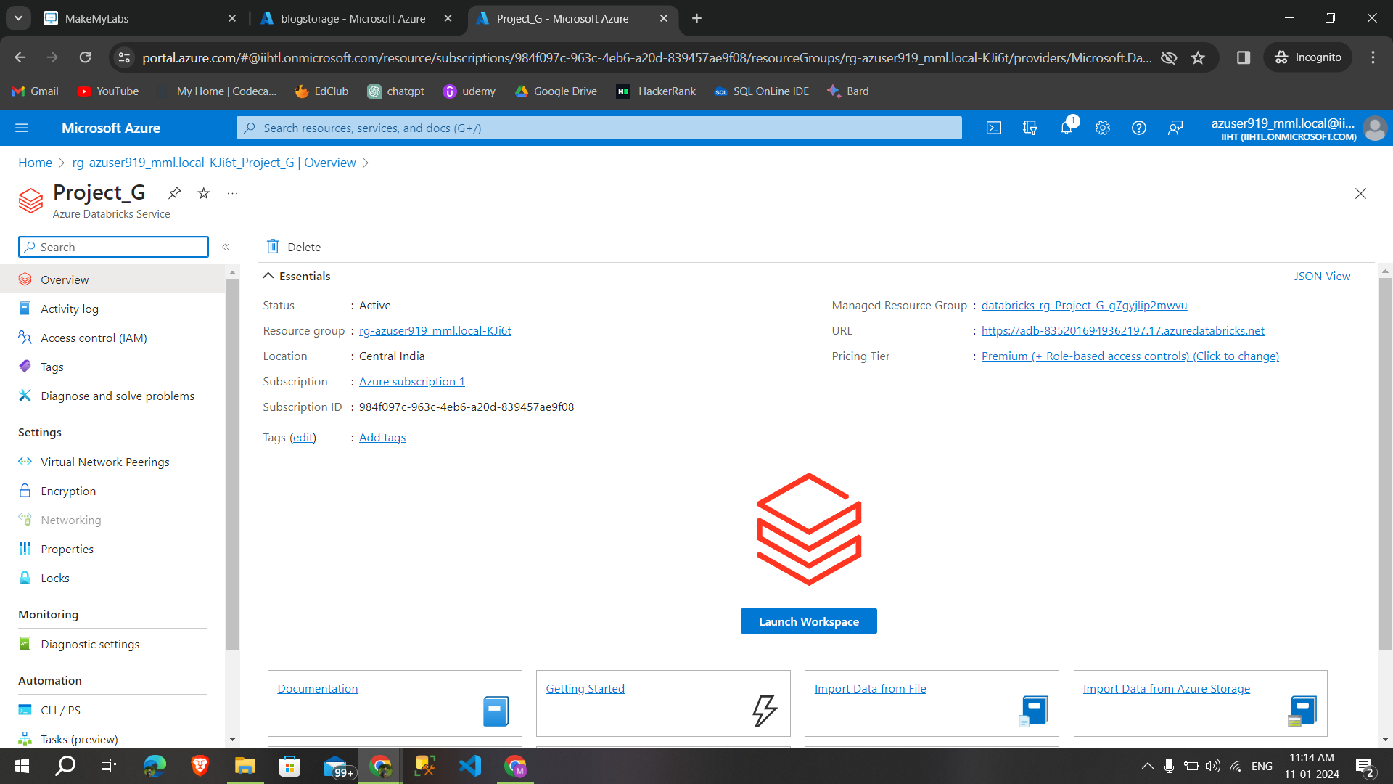

**Step 2:**This is the overview page of databricks workspace select compute to create a new cluster

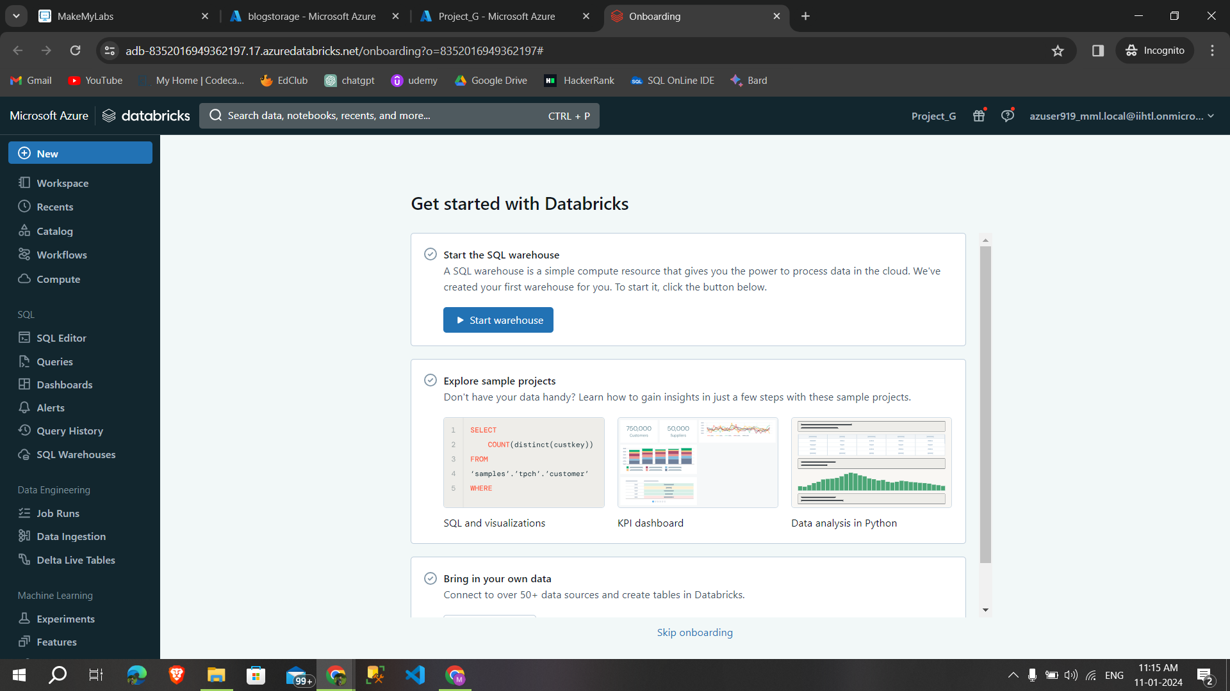

**Step 3:**Select the policy,runtime version,node type and click create compute to create cluster

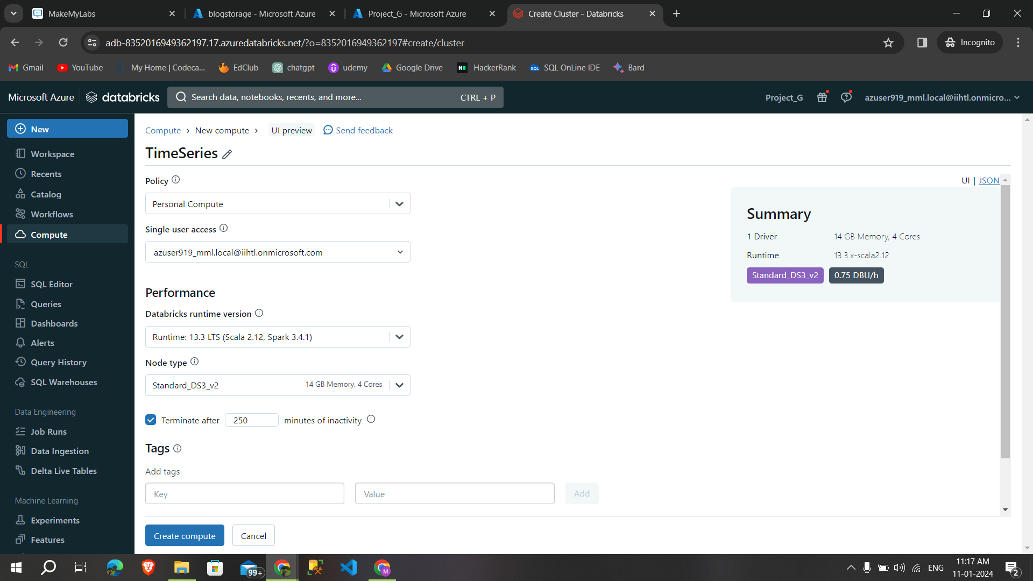

**Cluster is created successfully**

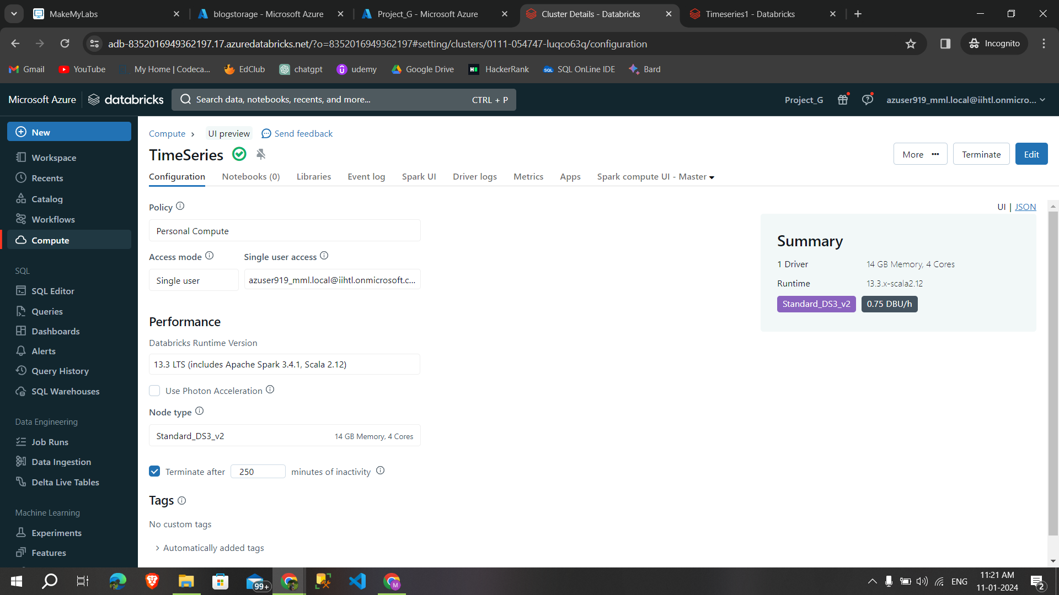

**7.7Creating a notebook**

* create a new notebook by clicking on new→notebook

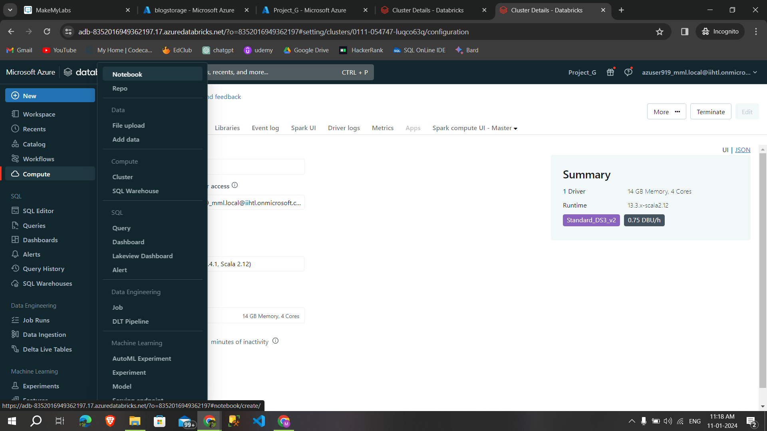

**7.8.Mounting the storage account in databricks**

**Step 1:**By using the dbutils command we can mount the storage account into the azure databricks with the help of access key

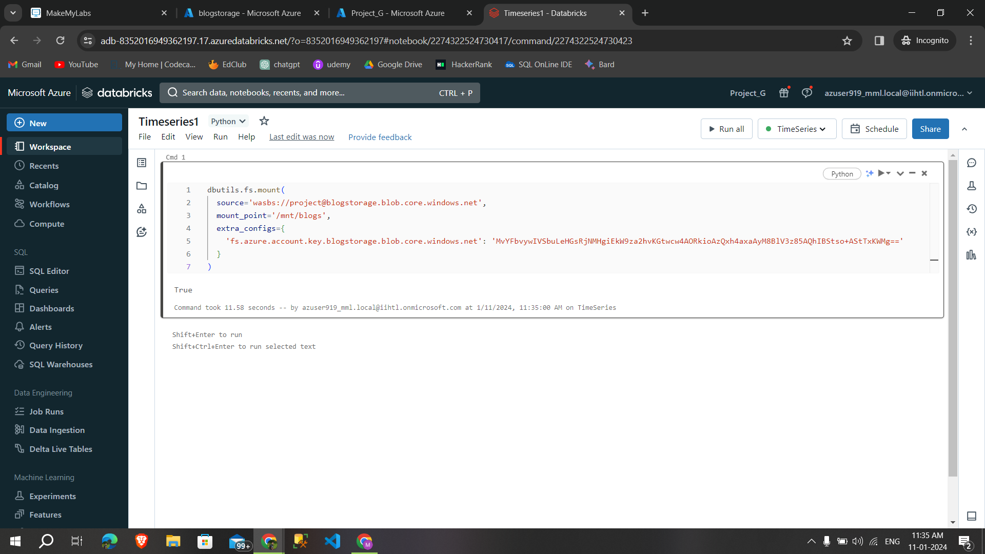

**Syntax for mounting the storage into databricks.**

* dbutils.fs.mount(source=’wasbs://containername@storageaccountname.blob.core.windows.net’,mount_point=’/mnt/mountpointname’,extra_configs={‘fs.azure.account.key.storageaccountname.blog.core.windows.net’:’access key’})

**Syntax for knowing how many files are in storage account are,**

* dbutils.fs.ls(‘mountpointname’)

**Step 2:** We can able to the files that are in the storage account

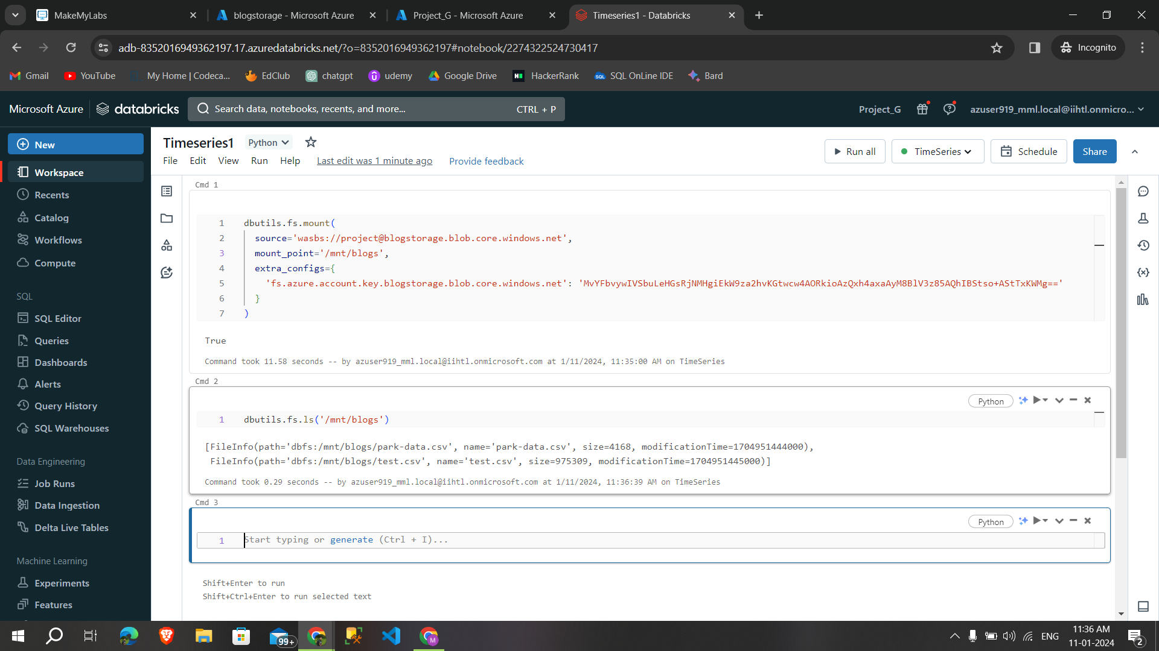

**Step 3:**read one of the files from storage account and displaying it,

**Syntax for reading a csv file:**

df.spark.read.csv(‘path/to/file/’,header=True,inferschema=true)

display(df)

**Syntax for creating a temporary view:**

df.createOrReplaceTempView(“name”)

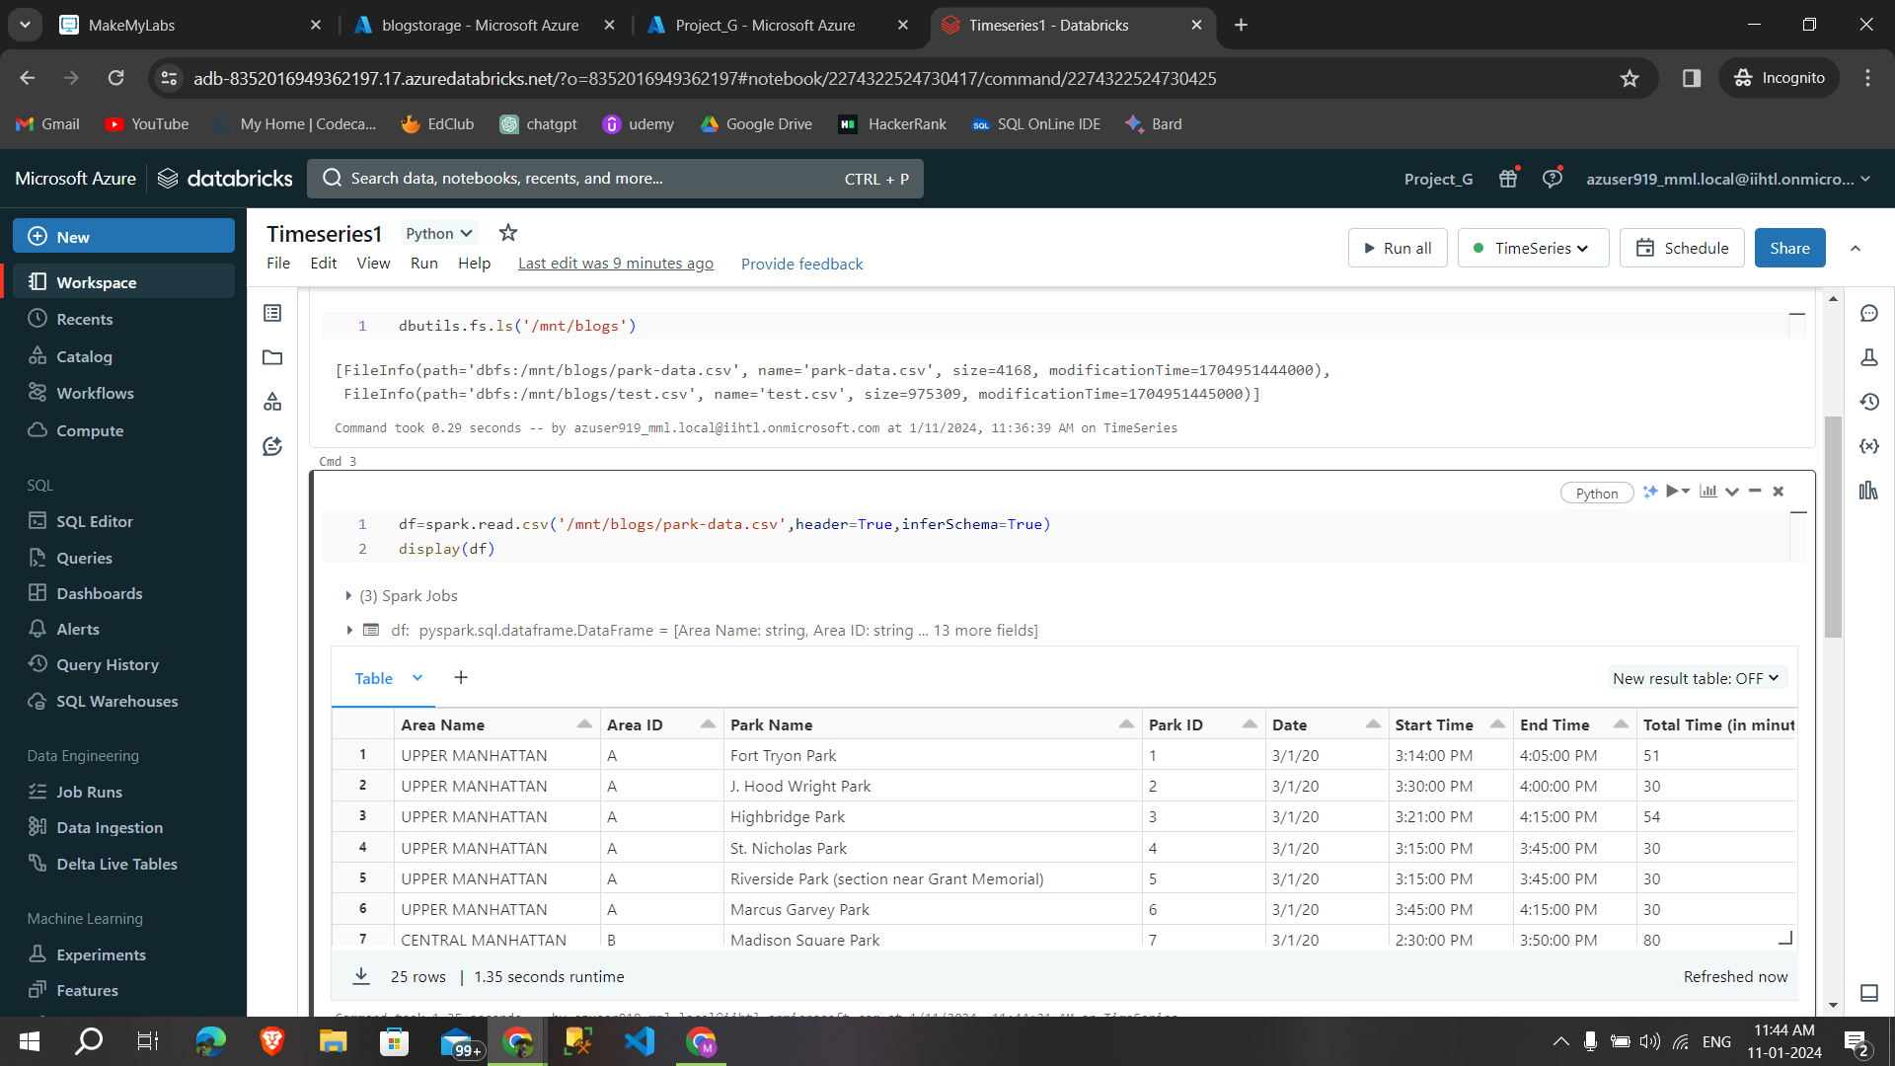

**Step 4:**Then creating a temporary view called timesdata for time analysis

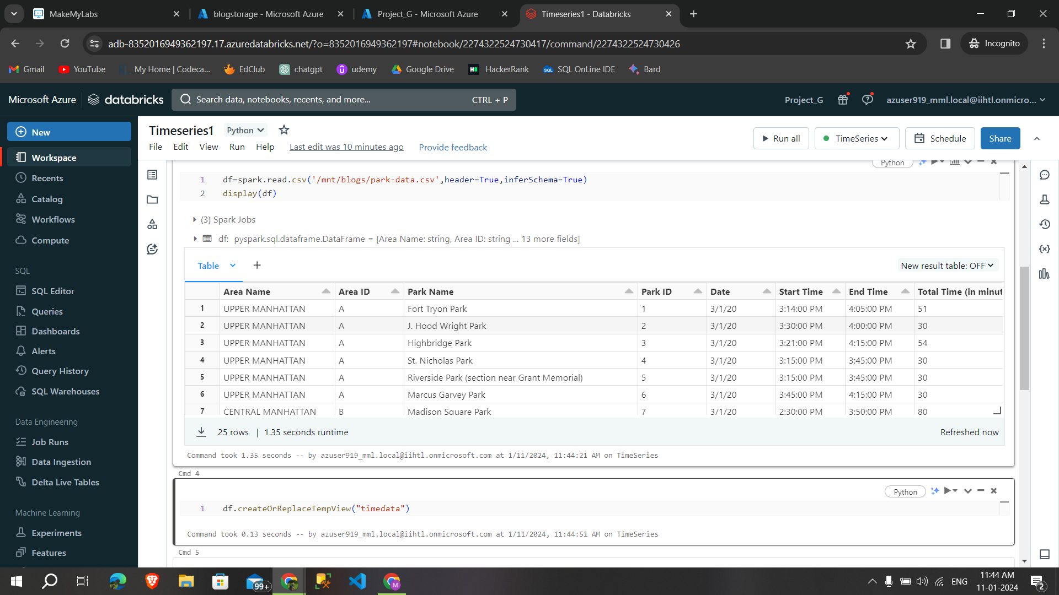

**7.9.Finding Trends on files**

**Trends:**

* It refers to the long-term movement or pattern in data over time. Identifying trends helps understand the overall direction and can be crucial for making predictions or strategic decisions.

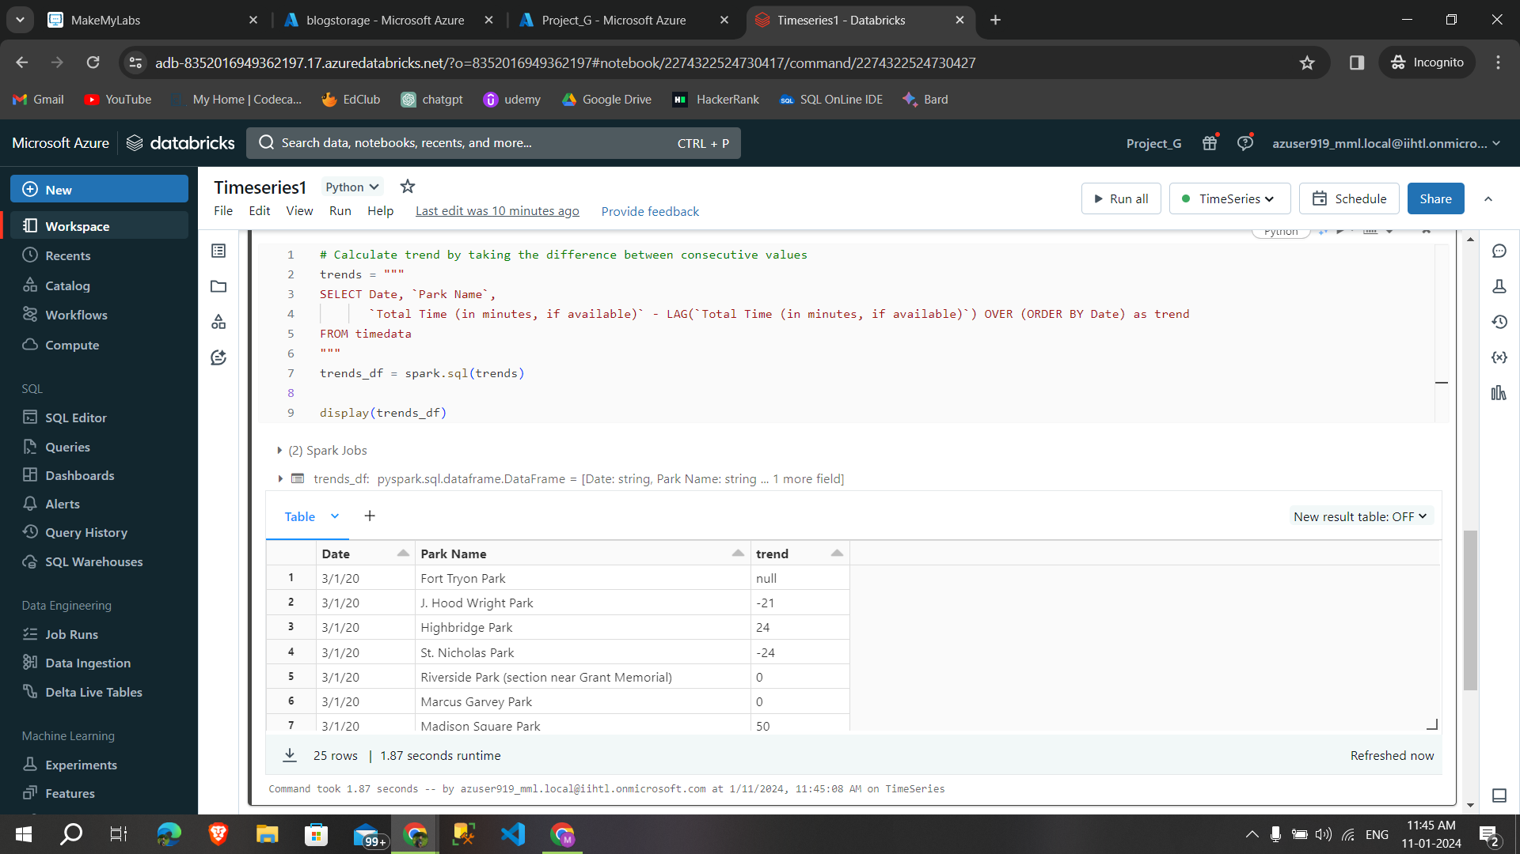

Code i used for finding trends :

# Calculate trend by taking the difference between consecutive values

trends_query_alternative = """

SELECT Date, `Park Name`,

`Total Time (in minutes, if available)` - LAG(`Total Time (in minutes, if available)`) OVER (ORDER BY Date) as trend

FROM time_series_data

"""

trends_df_alternative = spark.sql(trends_query_alternative)

display(trends_df_alternative)

**By adding Bar graph,line graph,scatter plots created a visualization and data profiles.**

**Bar Graph**

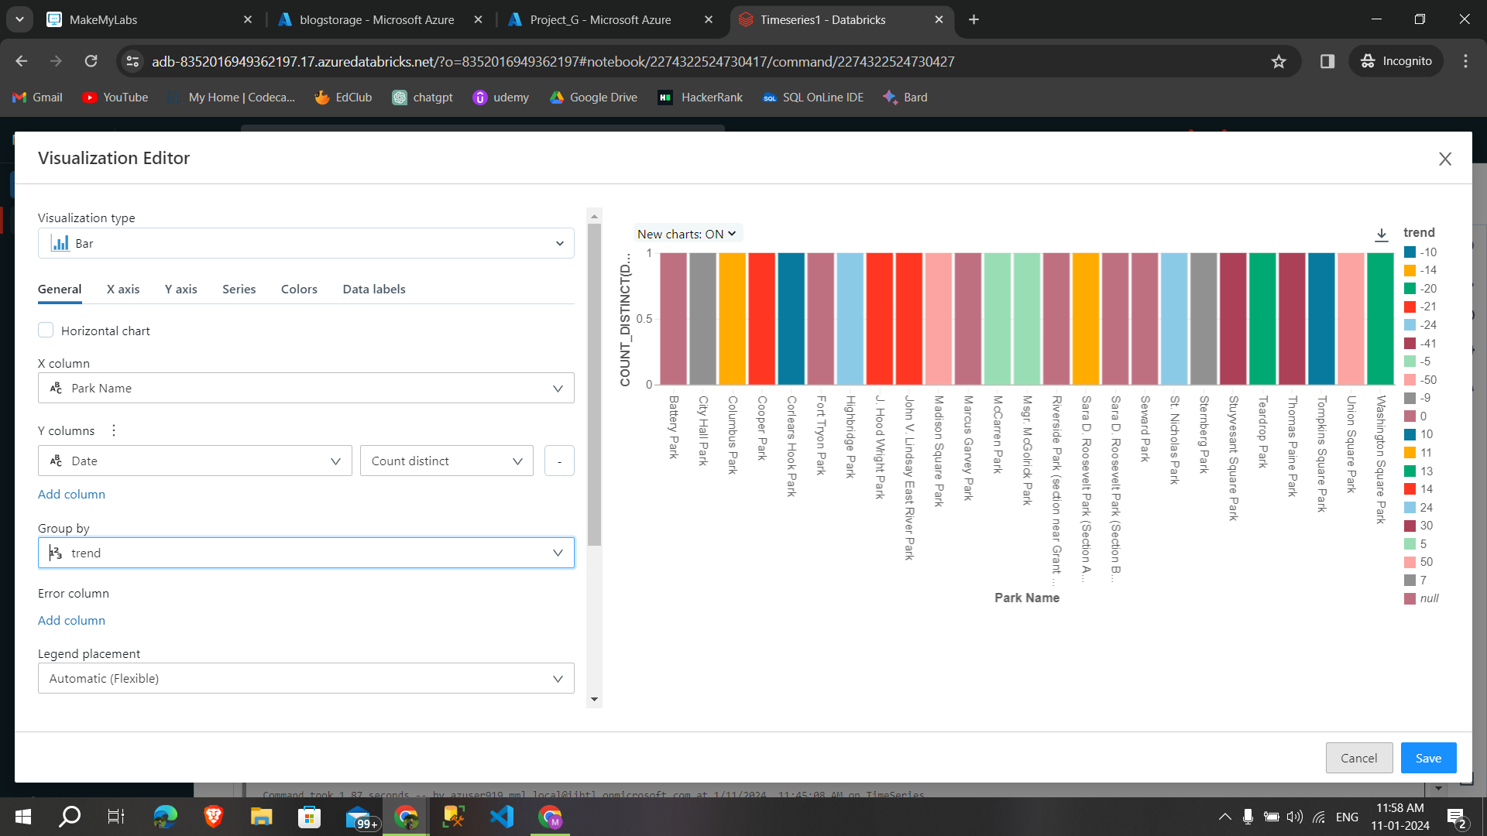

**Line graph** 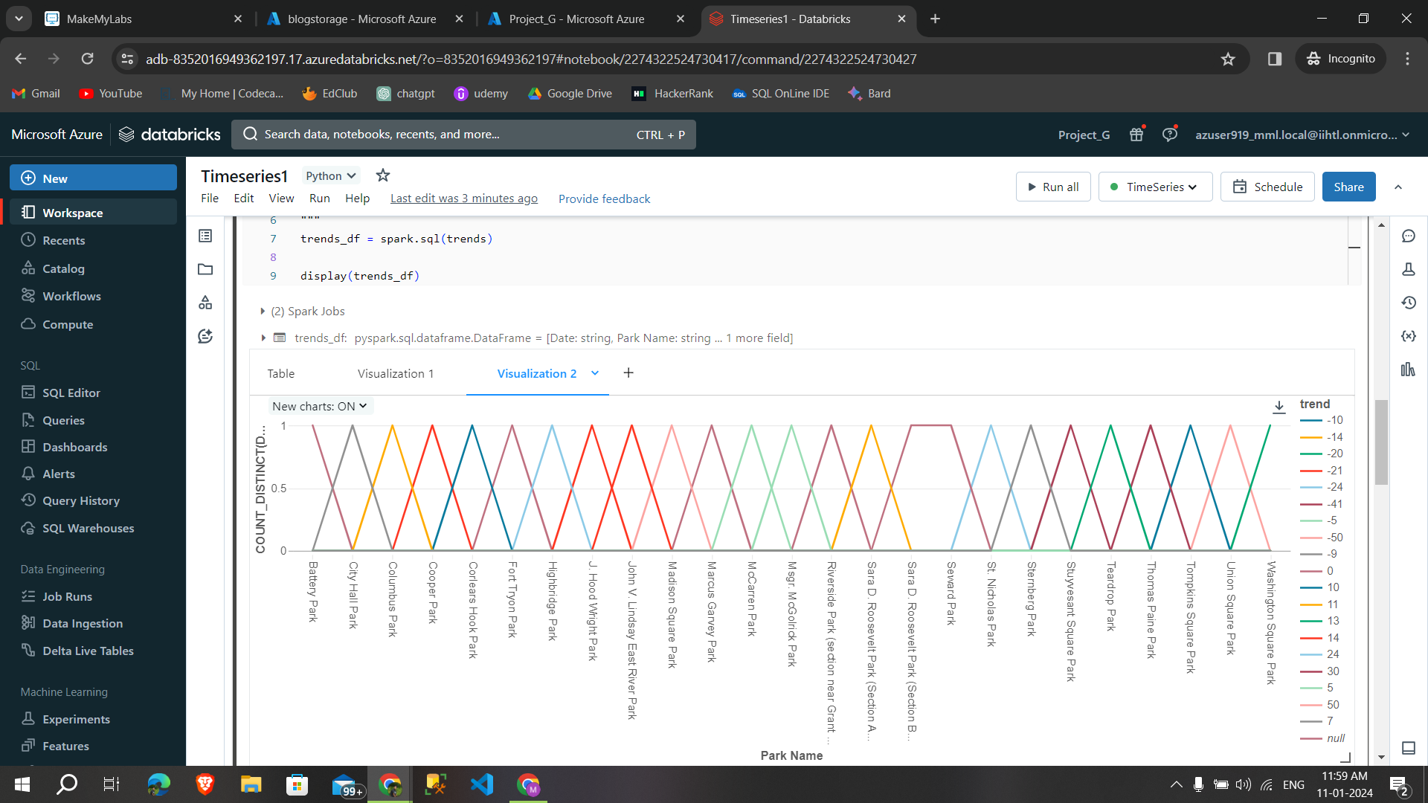

**Scatter plots**

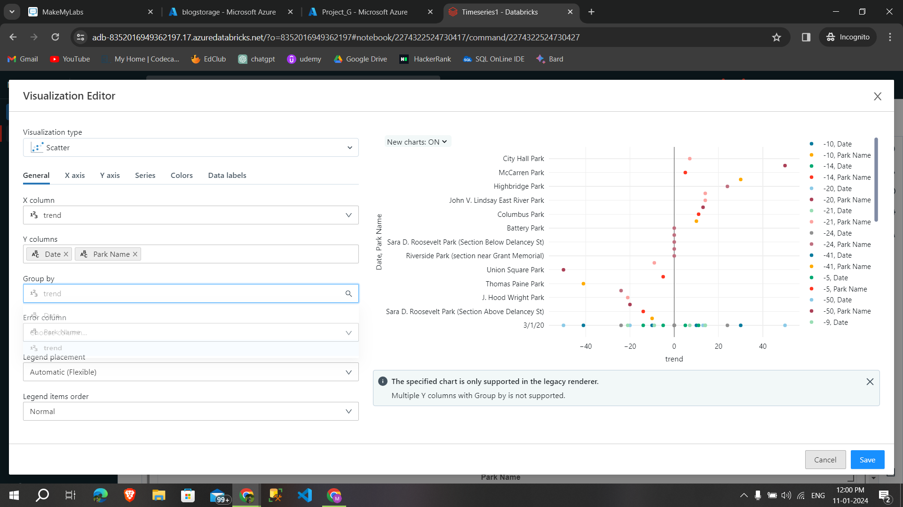

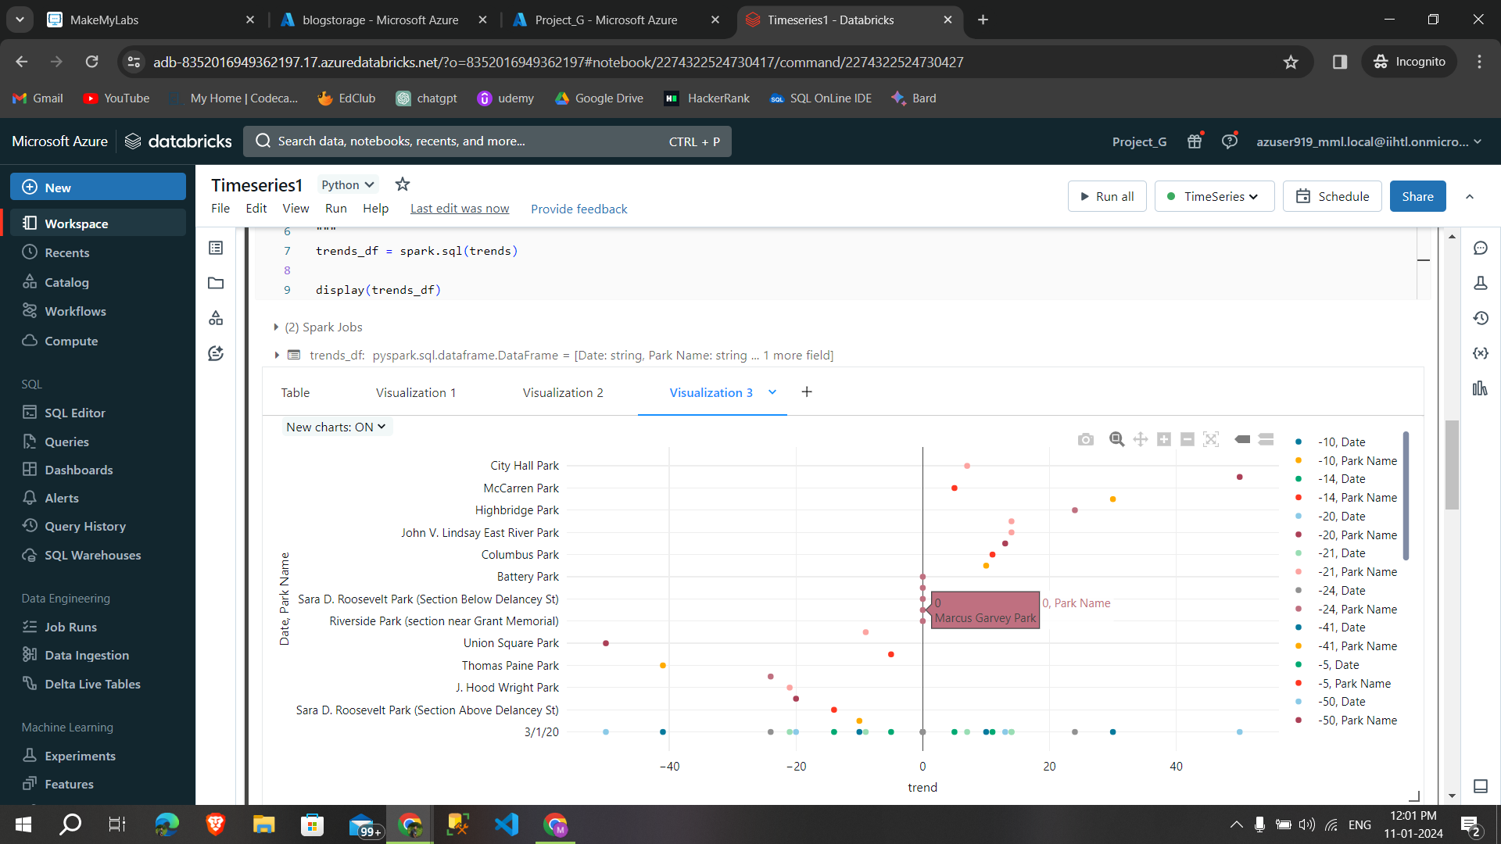

**Data profile**

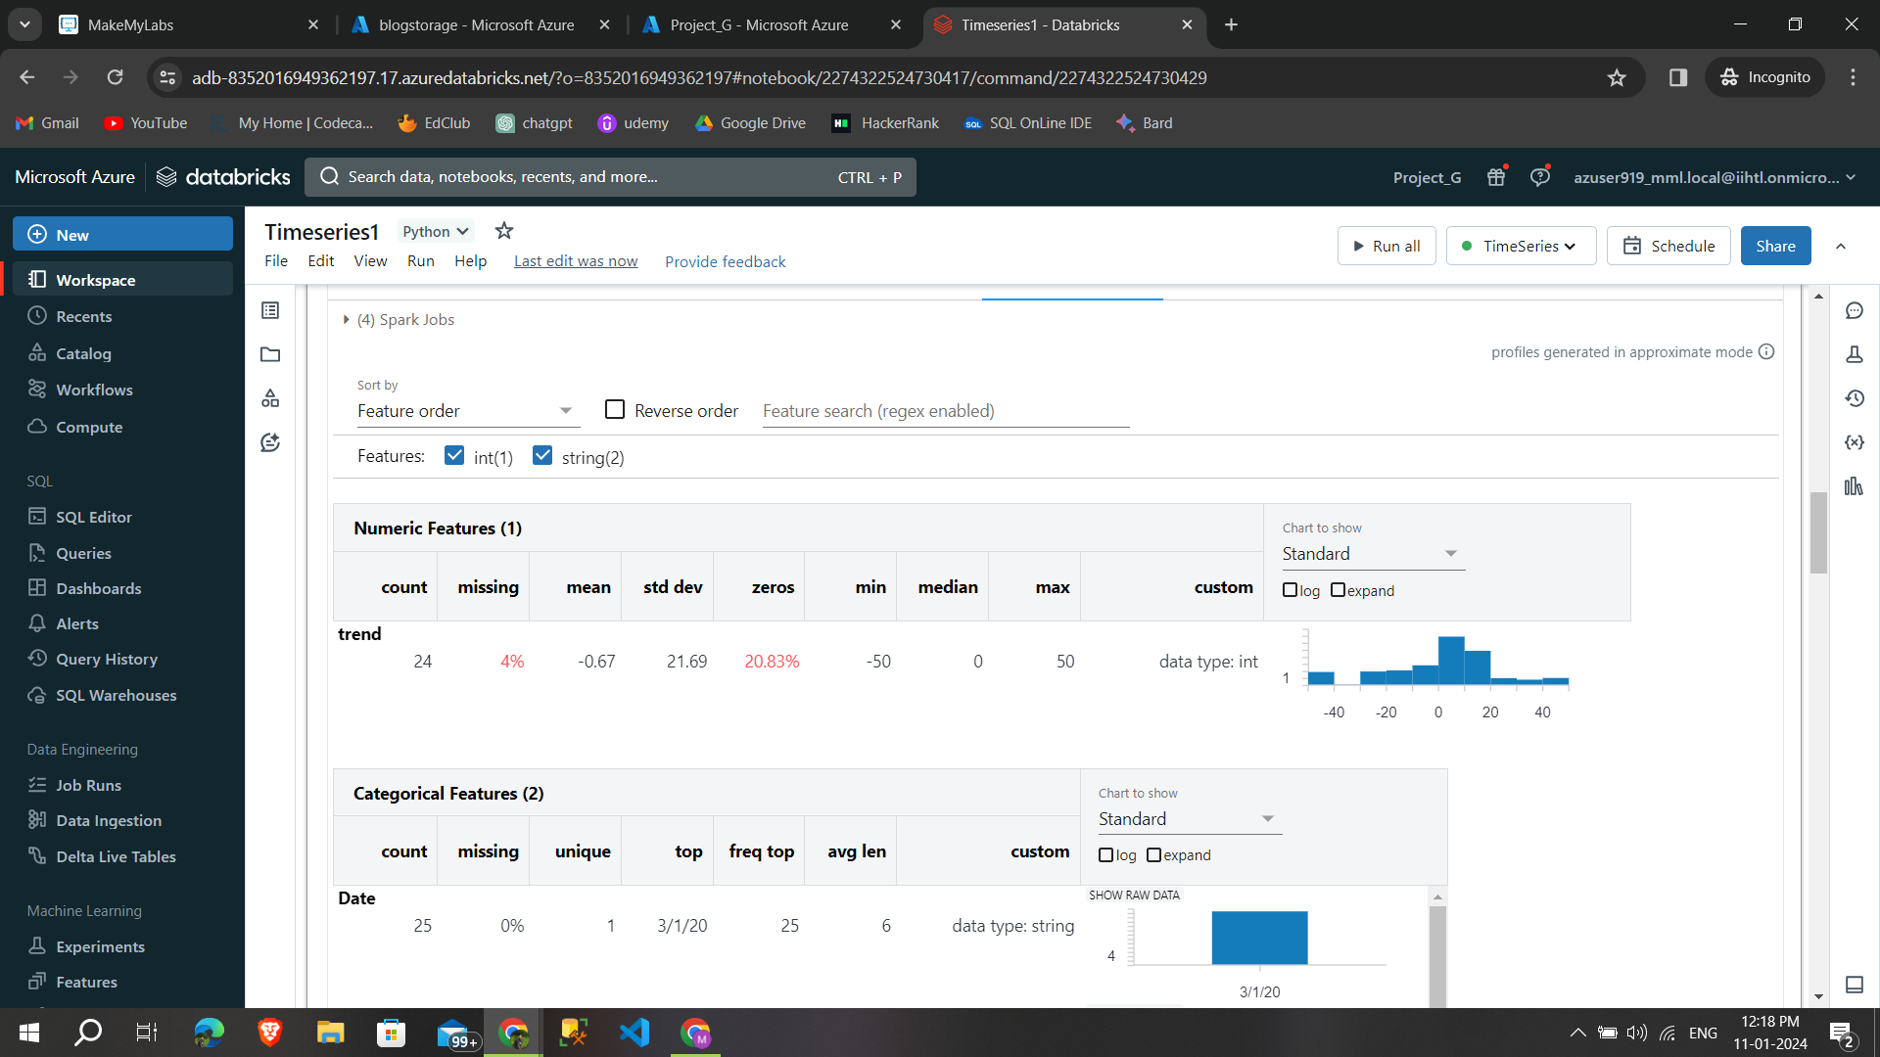

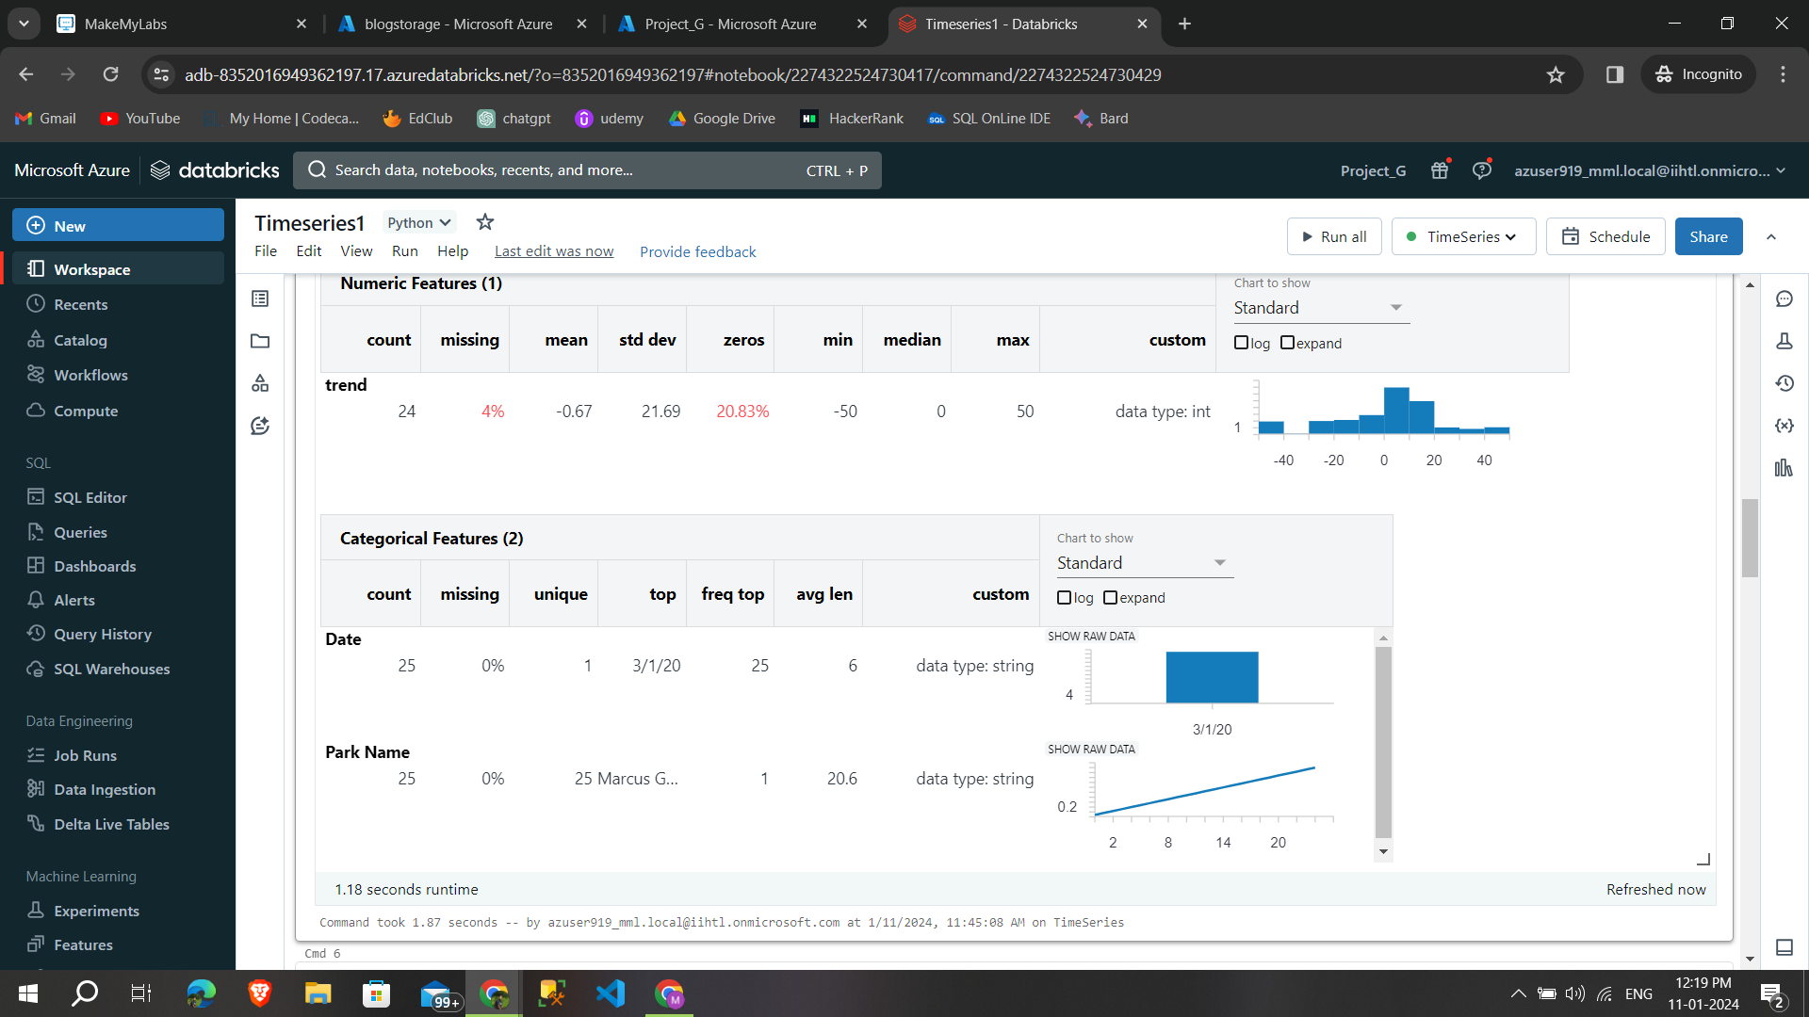

**7.10.Finding Seasonality on files**

**Seasonality :**

* It refers to the recurring and predictable variations in a time series that correspond to specific time periods, such as days, months, or seasons.

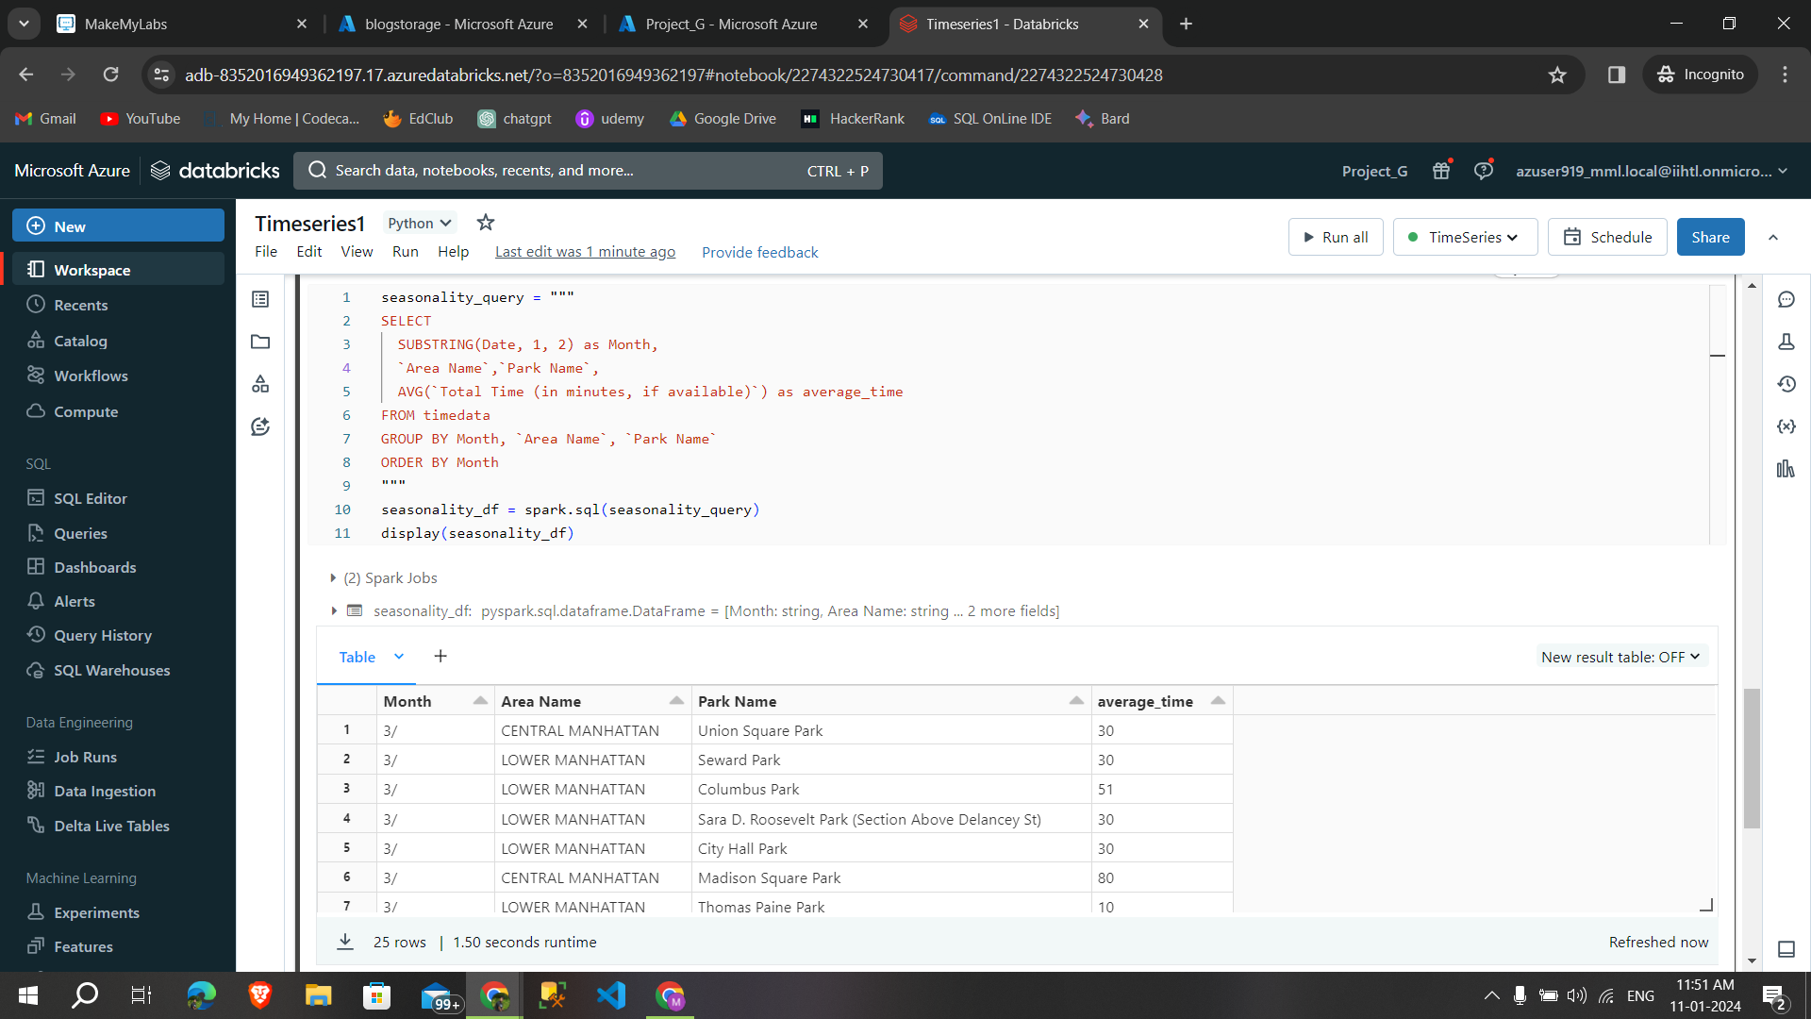

**Code I used to find the seasonality**

seasonality_query = """

SELECT

SUBSTRING(Date, 1, 2) as Month,

`Area Name`,`Park Name`,

AVG(`Total Time (in minutes, if available)`) as average_time

FROM timedata

GROUP BY Month, `Area Name`, `Park Name`

ORDER BY Month

"""

seasonality_df = spark.sql(seasonality_query)

display(seasonality_df)

**By adding Bar graph,area graph,histogram created a visualization and data profiles.**

**Bar graph**

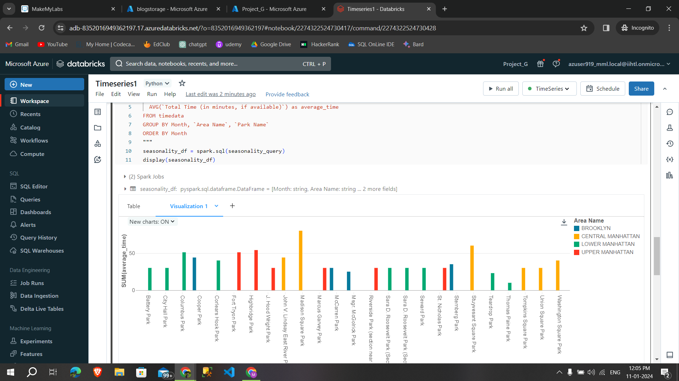

**Area graph**

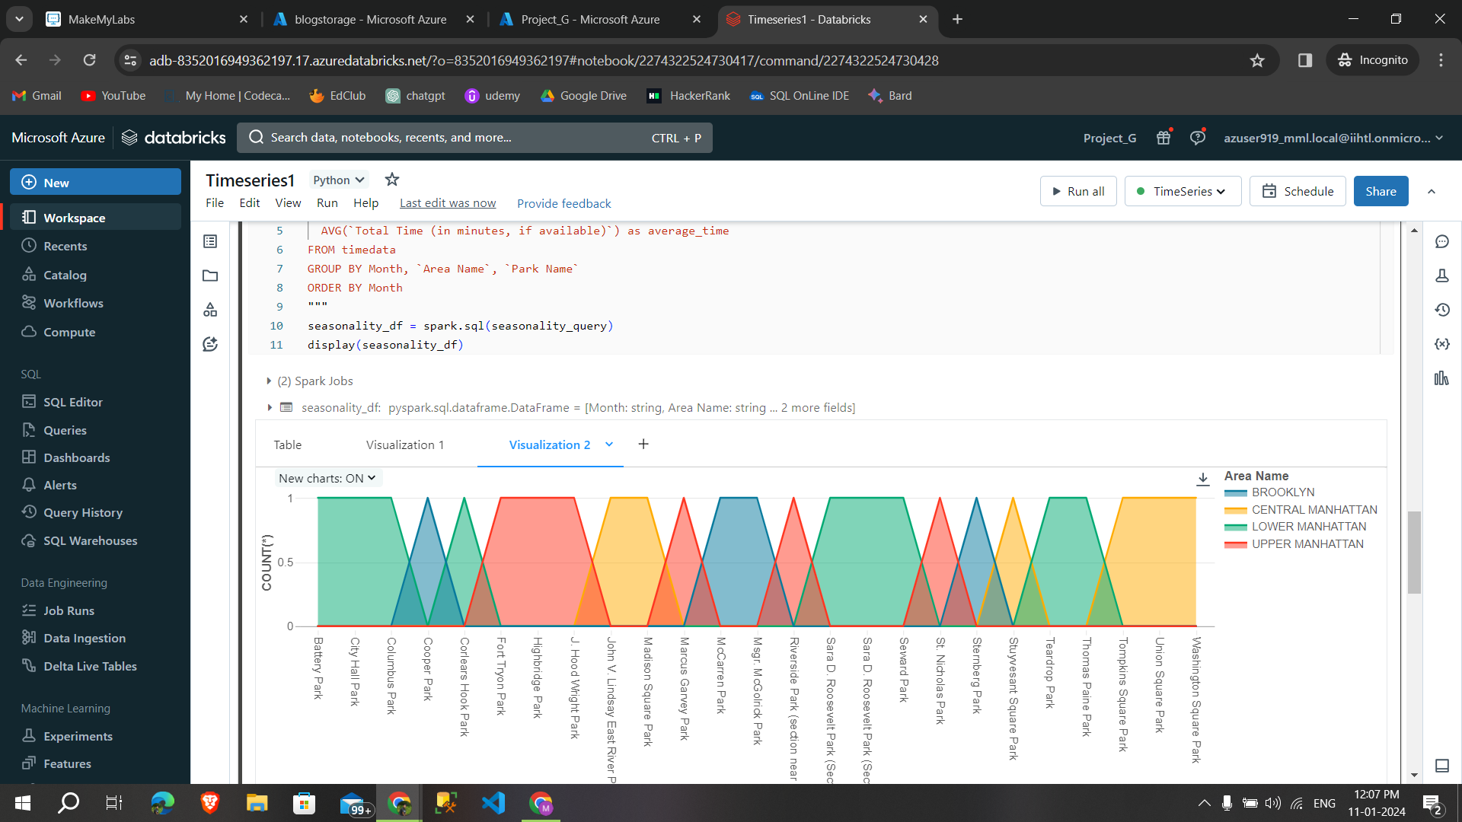

**Histograms**

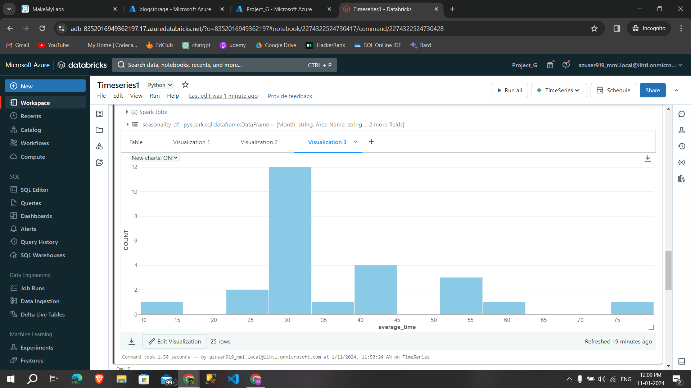

**Data profiles**

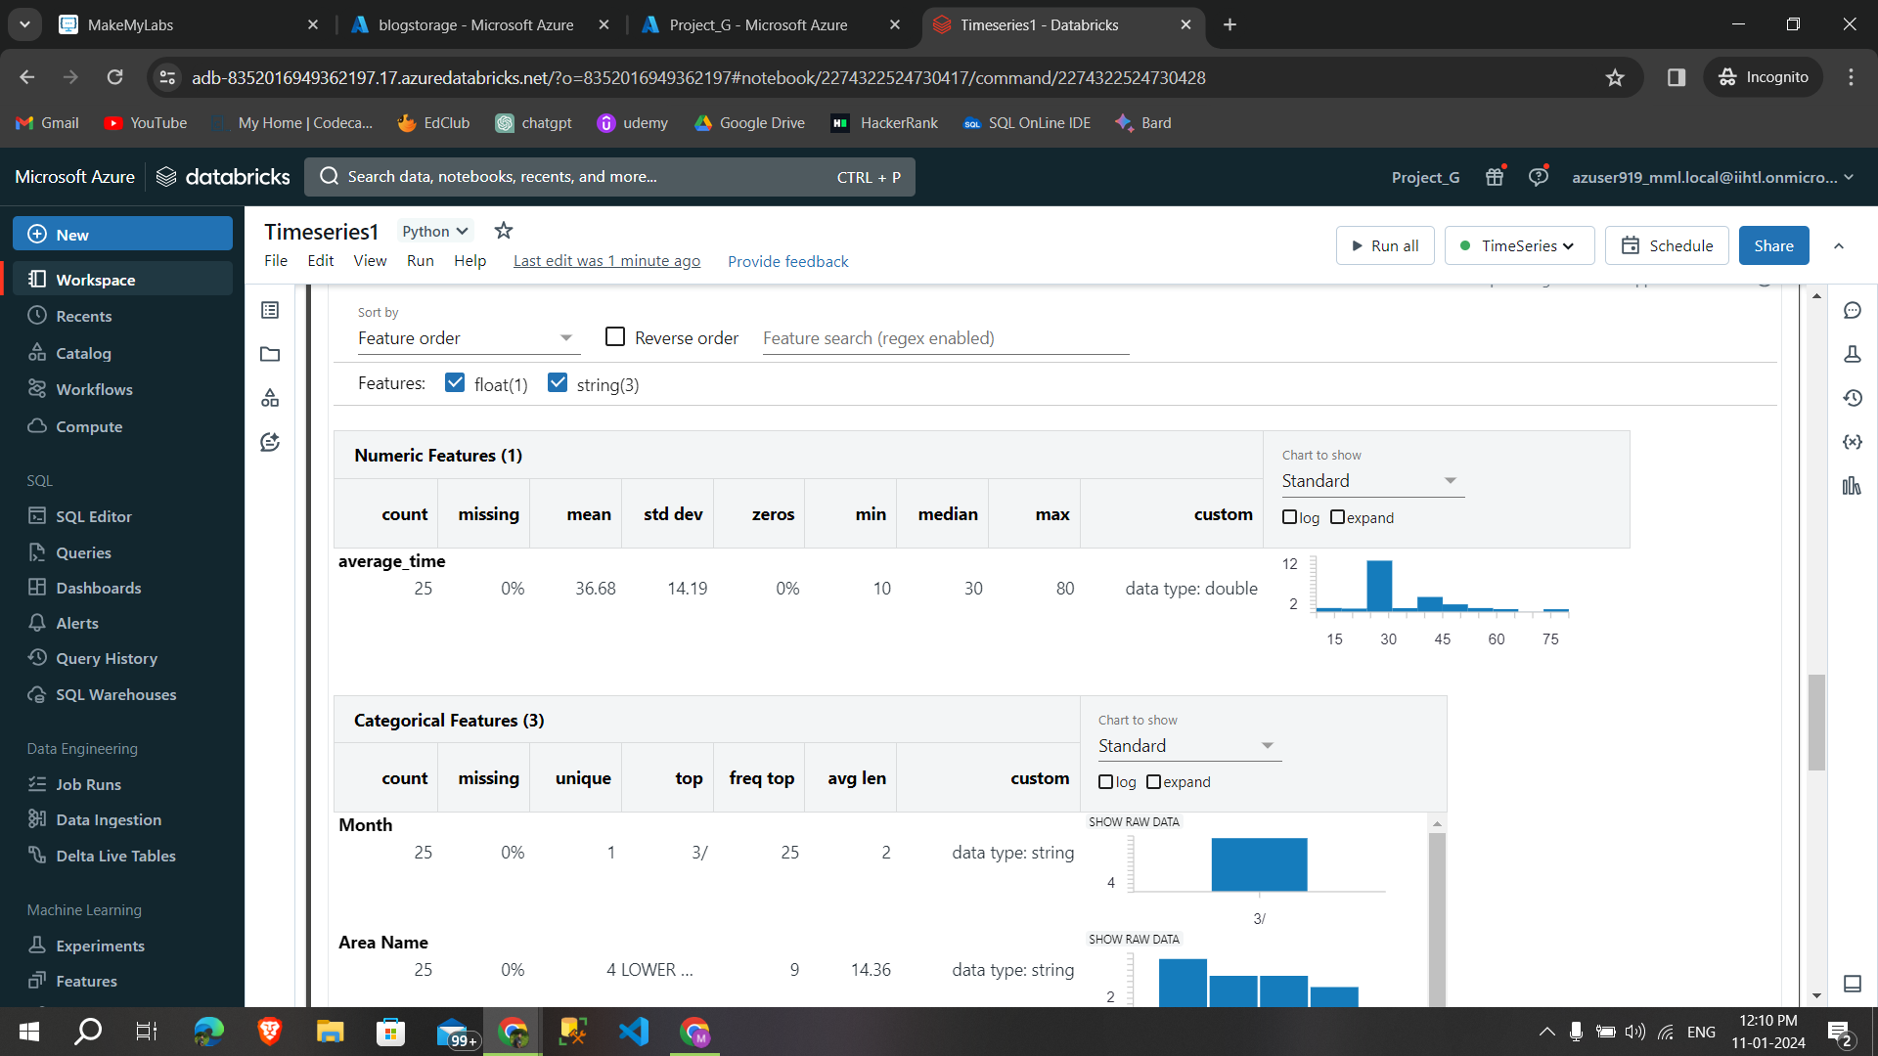

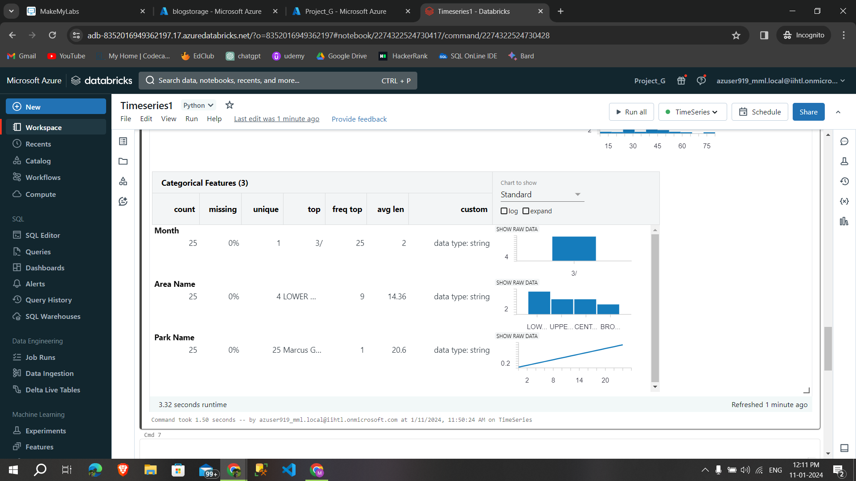

**7.11.Anomaly detection on files**

**Anomaly:**

* Anomalies, or outliers, in time series data represent data points that deviate significantly from the expected or normal behavior.

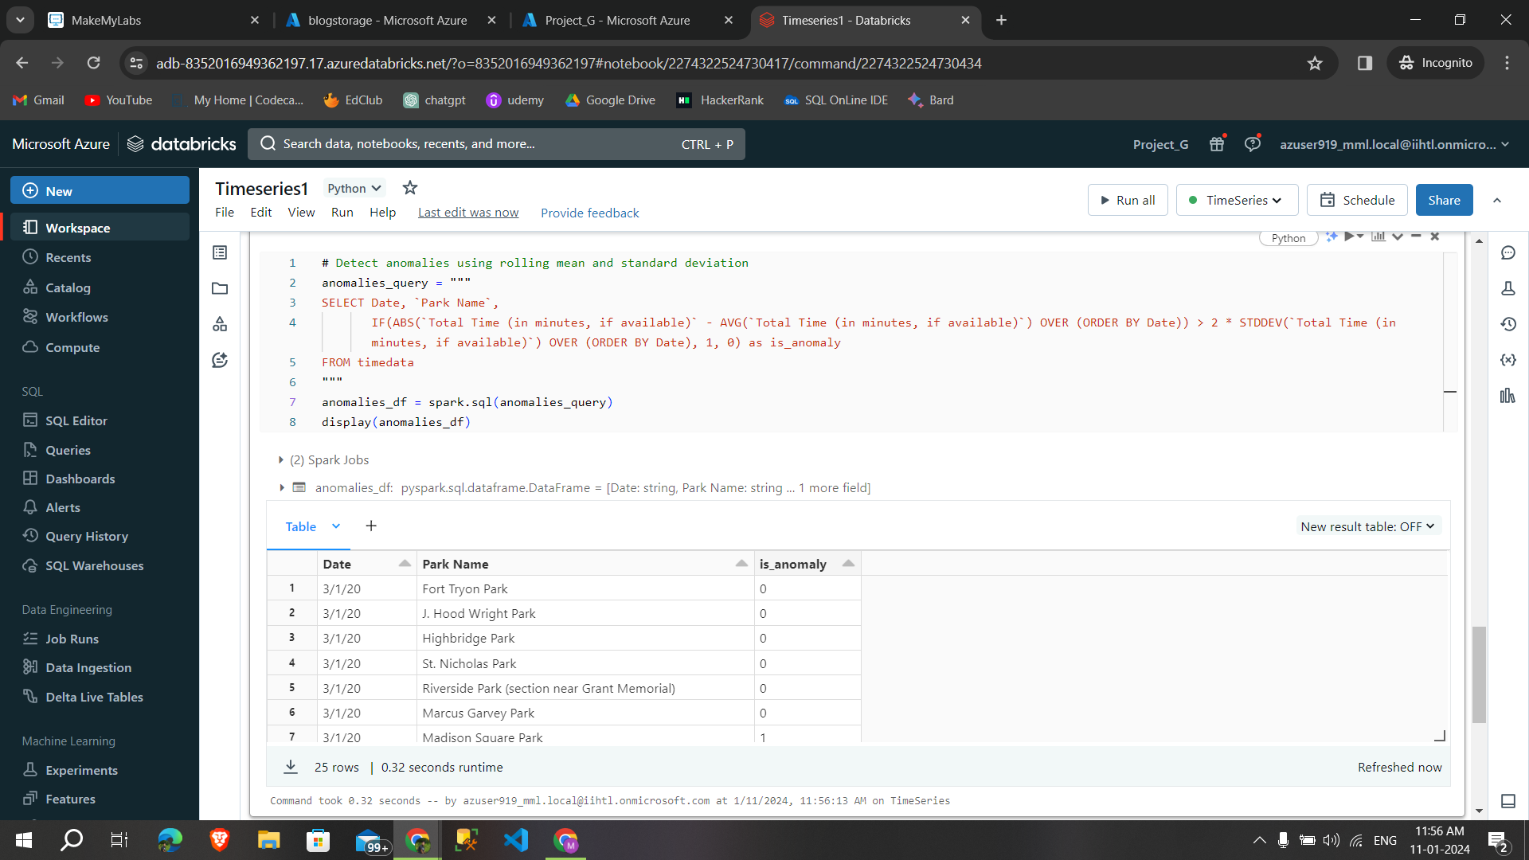

**Code I used for anomaly detection:**

# Detect anomalies using rolling mean and standard deviation

anomalies_query = """

SELECT Date, `Park Name`,

IF(ABS(`Total Time (in minutes, if available)` - AVG(`Total Time (in minutes, if available)`) OVER (ORDER BY Date)) > 2 * STDDEV(`Total Time (in minutes, if available)`) OVER (ORDER BY Date), 1, 0) as is_anomaly

FROM timedata

"""

anomalies_df = spark.sql(anomalies_query)

display(anomalies_df)

**By area graphs with different group by option created a visualization and data profiles.**

Area graph **group by date**

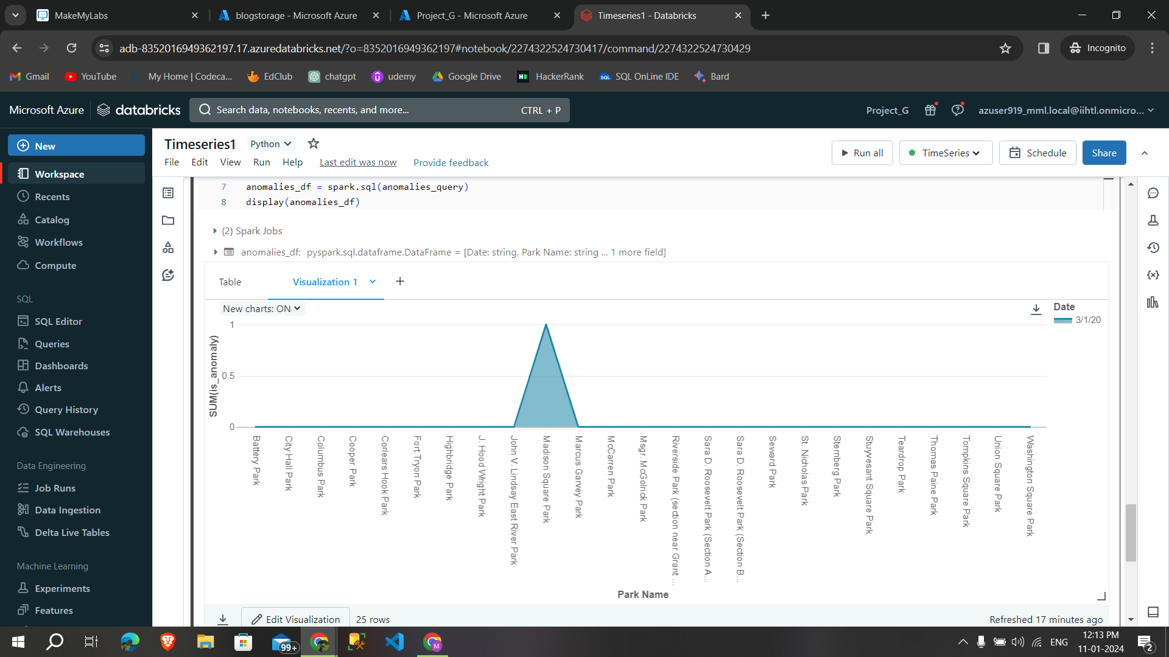

Area graph **group by anomalies.**

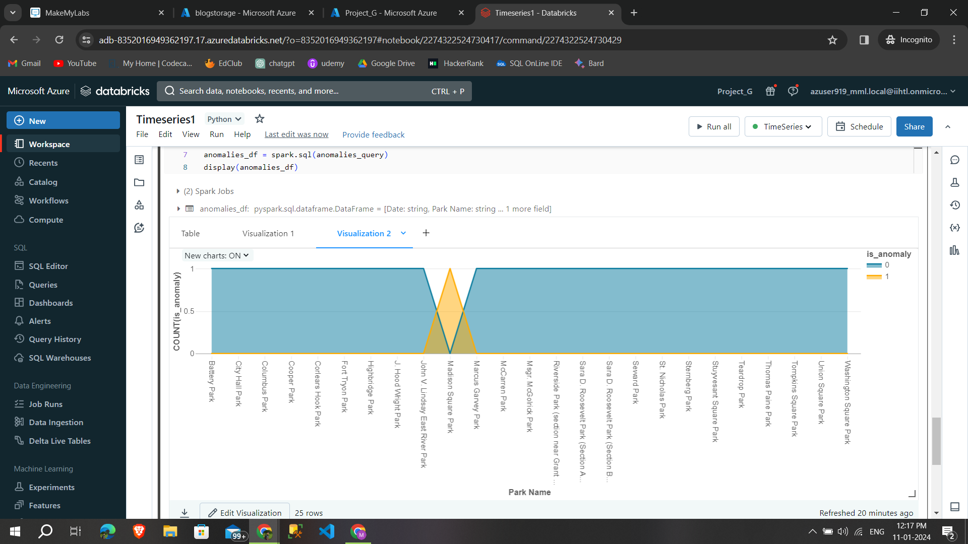

**Data profile**

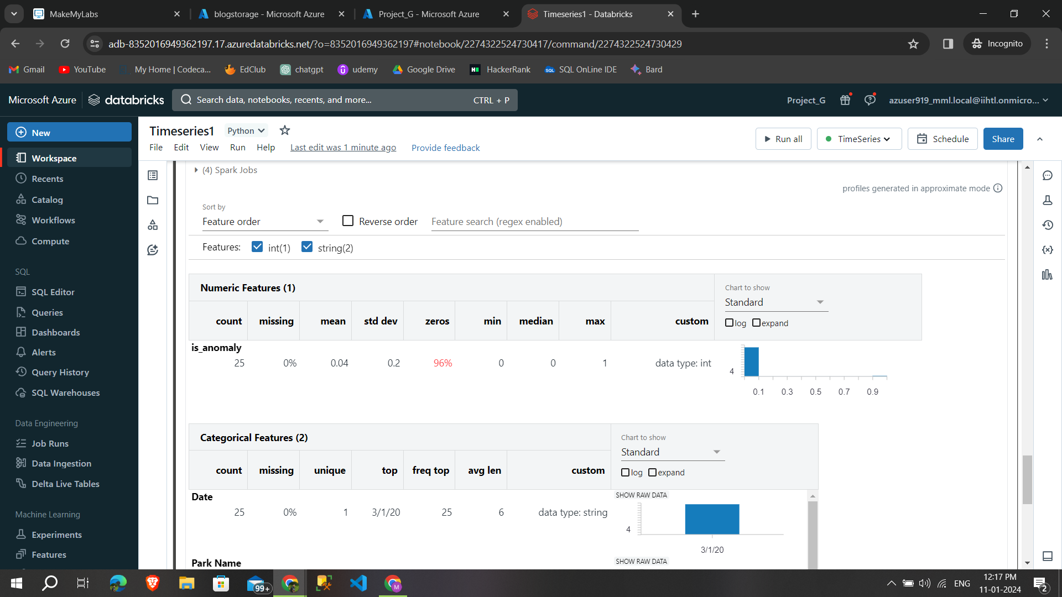

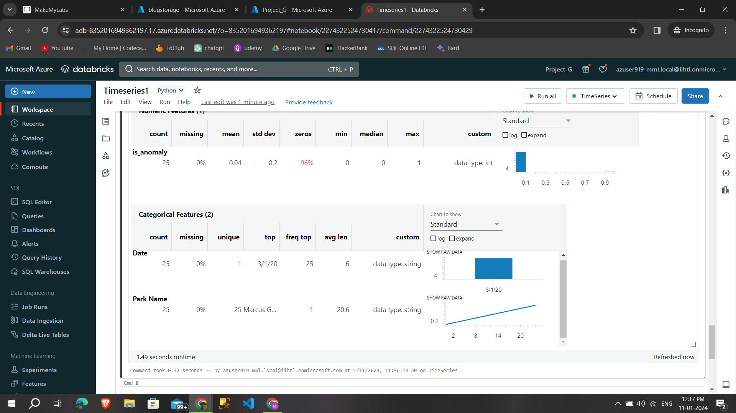

**Monitor them in the Spark UI**

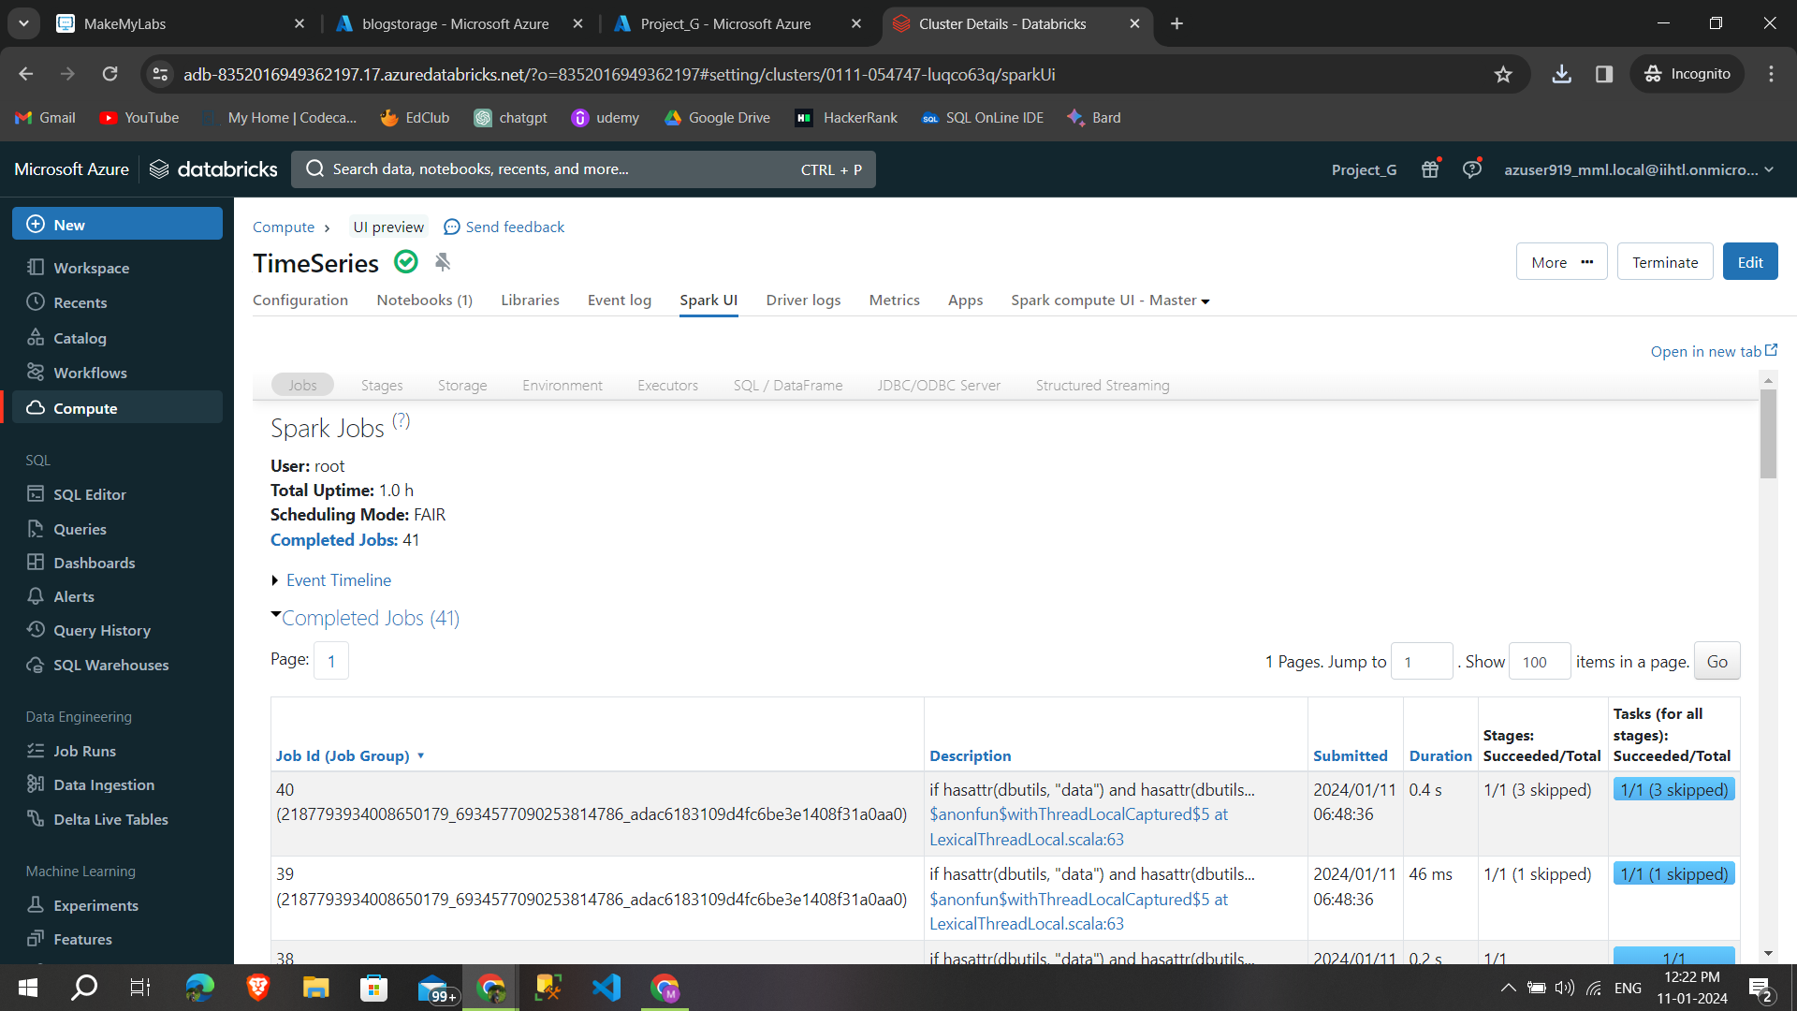

**7.12.Unmount the storage account from databricks**

By using following syntax unmount the storage account from databricks.

* **dbutils.fs.unmount(‘mountpointname’)**

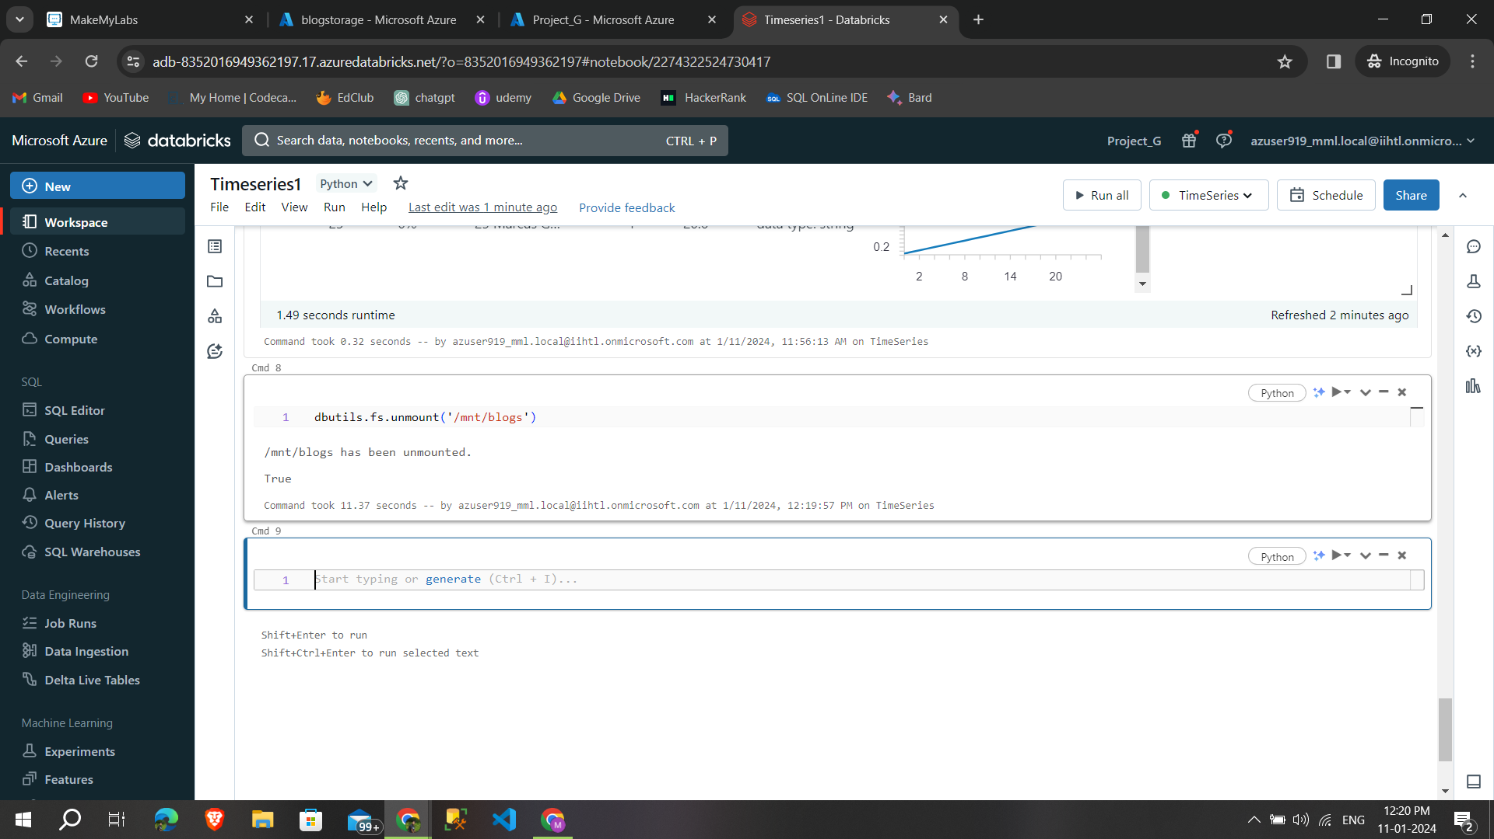

**8.Conclusion**

By following these steps, the project will demonstrate the effective use of PySparkSQL on Azure Databricks to perform comprehensive time series analysis on time-stamped data, uncovering valuable insights for trends, seasonality, and anomalies.